SNMP Plugin

Purpose
- The SNMP plugin gives the possibility to send metrics, alarms and metadata to any platform that can receive data via SNMP
- Once active, this plugin will collect all generated alerts and metrics and regularly post them to the defined server via SNMP
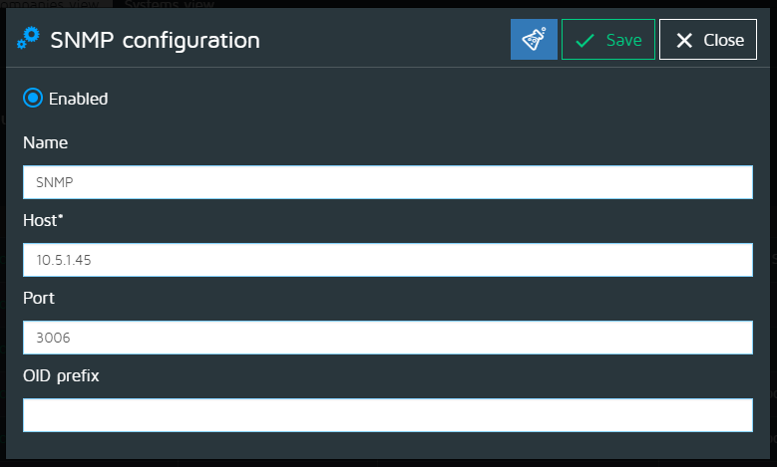

Configuration
- Enabled: To enable or disable the plugin
- Name: The name of the plugin to display in the list of plugins
- Host: The hostname of the target platform
- Port: The port to use to send the data
- OID prefix: : Racine identification node

