DB2 connector

Purpose
- With the DB2 connector, you can connect to an DB2 database via a JDBC driver.
- The database will then be monitored by querying information from the database with SQL requests
- To create connector, there are two steps:
  - Create a user in the database and register it in Redpeaks
  - Create and set connector parameters

Drivers
The driver db2jcc4 can be download on Maven repository : https://mvnrepository.com/artifact/com.ibm.db2.jcc/db2jcc/db2jcc4

Create user profile
- User profiles can be created via the Configure menu
- Once created, the user profile can be selected in the connector form
- Note: A user profile is by default associated with a company . You can explicitly set a profile to be cross companies. The effect is that it will be selectable from connectors of any companies.
- The corresponding user must be created in the database as well.

Create connector
- Select the system in the Systems tree and select “Add connector” in its contextual menu, choose DB2 type.
- Fill in the connector parameters:
  - Title The display name of the connector
  - Host: The hostname or IP address of the database host
  - Port: The port of the database service
    - If on Db2 Version 11.5.5 and older, the default port number is 50000.
    - If on Db2 Version 11.5.6 and newer, the default port number is 25000
  - Database name: The database to connect to
  - User: The user profile to use for the connection
  - Properties: Optional properties to add to the connection parameters (separated with semicolon (;)
Press Save & Test to save the profile and check the connection is working
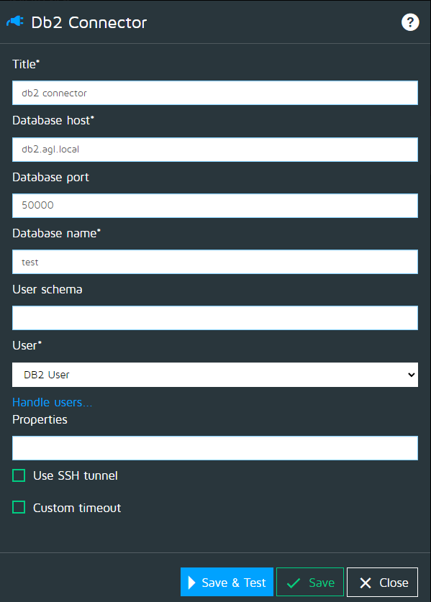

SSH
- In case you must connect to a database through an SSH tunnel, you can enable the SSH option and fill in the parameter:
  - Host: The host where the entrance of the tunnel is created.
  - Port: The local port of the SSH tunnel
  - User: The user to authenticate on the SSH end point.
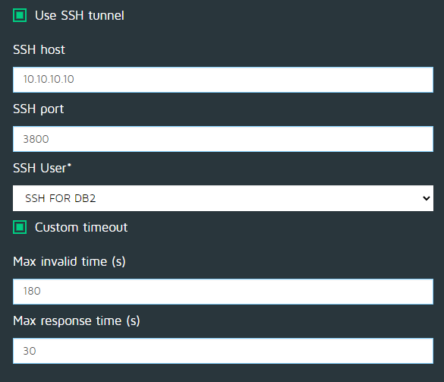

Custom timeout
- See Custom timeouts

Authorizations
The DB2 monitors will need to peform SELECT queries on the below tables:
In progress...

