7. MaxDB Connector

Purpose
- Use this connector to connect directly to a MAXDB Database.
- It will give access to all components that can be monitored through Redpeaks MAXDB monitors
- To create a MAXDB connector, there are two steps:
  - Create a user profile in the database and register it in Redpeaks (Redpeaks SAP User)
  - Create and set connector parameters
- Redpeaks MAXDB connector uses JDBC to connect to the Database and SQL queries to inquire the database

Creating a SAP user profile
- SAP user profiles can be reached via Systems->SAP users
- Create a new profile using the “Add” button
- Once created, the user profile can be selected in the connector form
- Note: A SAP User is by default associated with only one Group (Company). You can explicitly set a SAP User to be cross companies.
The effect is that it will be selectable from connectors of any company.
- The corresponding user must be created in SAP along with the appropriate authorizations.

Installing driver
- You must install MaxDB JDBC driver to connect to a MaxDB database
- Driver can be downloaded from maven repository
- Navigate to Setting->Updload/Download, and select upload other driver
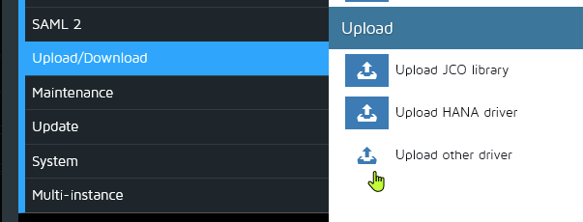

Creating the connector
- Select the system in the Systems tree and select “Add connector” in its contextual menu, then select “MAXDB” type.
- MAXDB connector input form will allow you configure it (see image below)
  - Title : This label will help you to identify the connector
  - Database host: the hostname or IP address of the System Database server
  - Database Port: the database port (Default 7200)
  - Database Name: Database to connect to
  - User: the SAP user profile to use for the connection
  - For specific settings “Use SSH tunnel” and “Custom timeout” see below section “Setting specific configuration”
- Press Save & Test to save the profile and check the connection is working
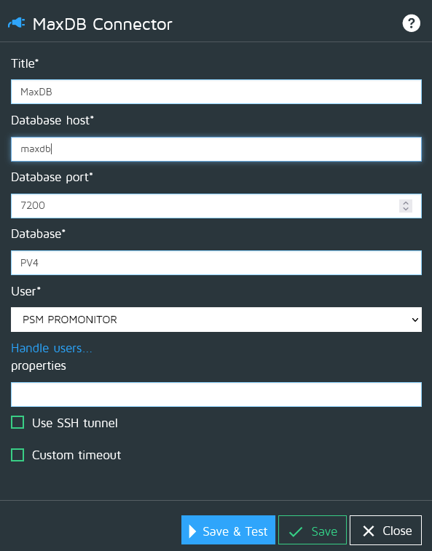

SSH
- In case you must connect to a database through an SSH tunnel, you can enable the SSH option and fill the parameters:
  - Host: The host where the entrance of the tunnel is created.
  - Port: The local port of the SSH tunnel
  - User: The user to authenticate on the SSH end point.

Custom timeout
- See Custom timeouts
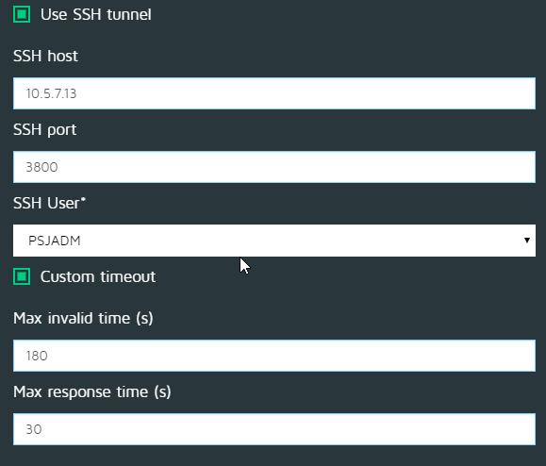

Monitoring user for MaxDB
- The connector requires a database SQLCLI user and a database operator DBMCLI user.
- Both users need to have the same username and password
- Please Note the password requirements for these users:
  - It must be in all CAPS.
  - It must be 8 characters or less.
  - Warning: Some symbols may cause problems when used in passwords, we know “$” works, however, be careful when using other symbols.
  - In some versions of MAXDB, you will need to use double quotes around <USER> and <PASSWORD>. (Double quotes not needed in the examples below)

Create SQLCLI user
- Open SAP MaxDB Command Prompt as Administrator
- Execute the following commands:
sqlcli -u SUPERDBA,<superdbapassword> -d <SID>
create user <monitoring_user> password <PASSWORD>
grant select on superdba.monitor_lock to <monitoring_user>
grant select on sysinfo.datavolumes to <monitoring_user>
grant select on sysinfo.datastatistics to <monitoring_user>
grant select on sysinfo.logstatistics to <monitoring_user>
grant select on sysinfo.cachestatistics to <monitoring_user>
grant select on sysinfo.instance to <monitoring_user>

Create DBMCLI user
- Open SAP MaxDB Command Prompt as Administrator
- Execute the following commands:
dbmcli -u SUPERDBA,<superdbapassword> -d <SID>
user_getall
user_create <monitoring_user>,<PASSWORD>
user_put <monitoring_user> SERVERRIGHTS=+DBInfoRead
user_get <monitoring_user>

Driver properties
- See MaxDb driver properties

