6. Sybase Connector

Purpose
- With a Sybase connector, you can directly connect to a Sybase Database.
- It will give access to all components that can be monitored trough Redpeaks Sybase monitors
- To create a Sybase connector, there are two steps:
  - Create a user profile in SAP and register it in Redpeaks (Redpeaks SAP User)
  - Create and set connector parameters
- Redpeaks Sybase connector uses JDBC to connect to the Database and SQL queries to inquire the database

Creating a SAP user profile
- At first step, create a SAP user is the SAP system
  - Find an step-by-step example creating a SAP user with Read access on a table in Sybase under SAPSR3DB schema at the bottom of this page
- SAP user profiles can be reached via Systems->SAP users
- Create a new profile using the “Add” button
- Once created, the user profile can be selected in the connector form
- Note: A SAP User is by default associated with only one Group (Company). You can explicitly set a SAP User to be cross companies.
The effect is that it will be selectable from connectors of any company.
- The corresponding user must be created in SAP along with the appropriate authorizations.

Creating the connector
- Select the system in the Systems tree and select “Add connector” in its contextual menu, then select “Sybase” type.
- Sybase connector input form will allow you configure it (see image below)
  - Title : This label will help you to identify the connector
  - Database host: the hostname or IP address of the System Database server
  - Database Port: the port to access the Database
  - User: the SAP user profile to use for the connection
  - For specific settings “Use SSH tunnel” and “Custom timeout” see below section “Setting specific configuration”
- Press Save & Test to save the profile and check the connection is working
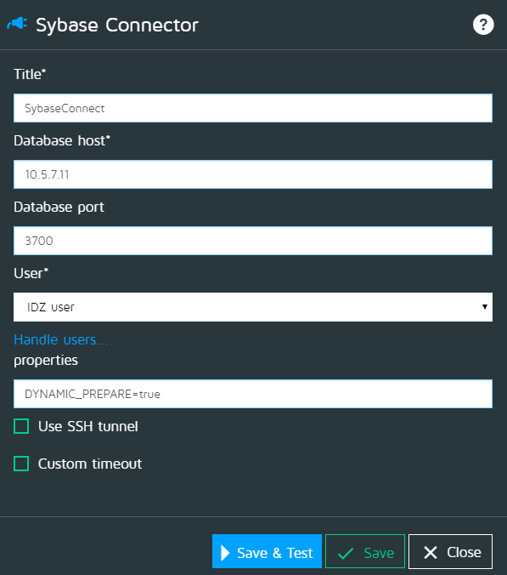

SSH
- In case you must connect to a database through an SSH tunnel, you can enable the SSH option and fill the parameters:
  - Host: The host where the entrance of the tunnel is created.
  - Port: The local port of the SSH tunnel
  - User: The user to authenticate on the SSH end point.

Custom timeout
- See Custom timeouts
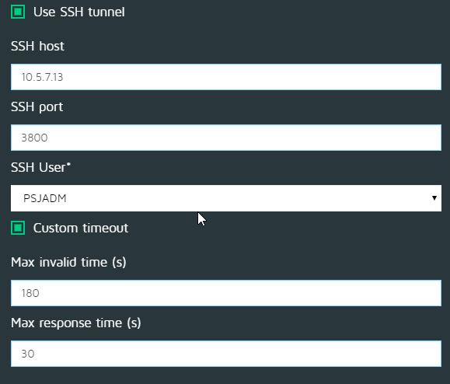

Authorizations
Redpeaks will gather information with the following means:
Stored procedures:
- sp_dump_history
  - With granular permissions enabled, you must be a user with manage dump configuration privilege
  - With granular permissions disabled, you must be a user with sa_role or oper_role
- sp_spaceusage
  - Any user can execute sp_spaceusage to view space usage. However, you may not be able to view certain information about tables that you do not have permissions to view.
- sp_helpdb
  - Any user can execute sp_helpdb
Tables:
- master..sysusages
- master.dbo.monThread
- master.dbo.monDeadLock
- master.dbo.monErrorLog
- master..sysdatabases
- master..monDeviceSpaceUsage
Example of role creation:
If you want to create a SAP user with Read access on a table (t1 in this example) of SAPSR3DB schema, you will have to follow the following:
- Create a new role “test_role” as below
USER MASTER
GO
CREATE ROLE test_role
GO
- Create a new login user “testuser” to access by example your database SAPSR3DB
sp_addlogin testuser, testuser, SAPSR3DB
GO
USE SAPSR3DB
GO
sp_adduser testuser , testuser
GO
- Grant READ (SELECT) permission to the new role
GRANT SELECT on t1 TO test_role
GO
- Grant the role to the required login user
USE MASTER
GO
GRANT ROLE test_role TO testuser
GO
sp_modifylogin testuser, "add default role", test_role
GO
- Grant EXECUTE permission to the new role
GRANT EXECUTE ON my_procedure TO role

