Installation problems

Service doesn't start
- The installer ran successfully, but you can't reach the UI with your web browser.

How to investigate
- Open the services screen in windows task manager
- Check that Pro.Monitor service is installed and running
- If it is not running, you probably had problem during service installation.

How to fix
- Open a windows shell and go to [ProMonitor install path]\bin
- execute: services.bat install ProMonitorTest
- If you see an error message relating JAVA_HOME env variable:
  - Check you installed only the java JRE and not JDK
  - Set JRE_HOME=[Java install path] in your environment variables (Not adding the bin folder), by Example: C:\Program_Files\Java\jre1.8.0_171
  - Remove JAVA_HOME variable
  - Open a new windows shell and go to [ProMonitor install path]\bin
  - Execute sc delete Pro_Monitor
  - Execute services.bat install Pro_Monitor
  - if the command is successfull, then the service can be installed correctly.
  - Execute sc delete Pro_Monitor to remove it again and let the installer do the job.
  - Uninstall ProMonitor by running the uninst000.exe file from Pro.Monitor install folder.
  - Execute the installer again, the service should be created correctly this time.
- If you see an error saying “Problem finding JAVA”:
  - Run the pro_monitorw.exe program from *bin* folder, Tomcat property screen will open.
  - Got to java section and check that Java Virtual Machine section is well configured: It must point to the bin\server\jvm.dll file
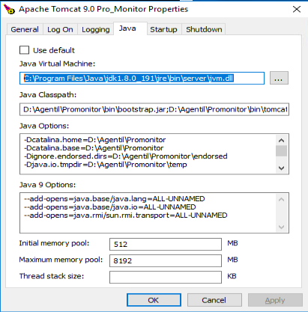

All connectors stay in UNKNOWN state
- You can log in the server, but monitoring doesn't seem to work: Perhaps the worker cannot find java:
  - Remove folder C:\ProgramData\Oracle
  - Remove any java.exe or javaw.exe file in C:\Windows\system32 and C:\Windows\SysWOW64
  - Make sure that the PATH SYSTEM variable contains the path to java.exe

