ABAP Connections issues

Authorizations

Symptom
- Connection error message such as
No RFC authorization for function module RFCPING

Resolution
- The connection user must be associated with a mandatory authorization profile
- Use PFCG transaction and look for Z_AGENTIL_SOFTWARE_PROMONITOR
- Check that the below actions have been performed:
  - Use Role->Upload to import the profile in the system
  - Edit the profile and navigate to Authorizations tab
  - Press Change authorization data button
  - Press Generate, then Save
  - Use SU01 to assign the profile to the user
- If the profile already exists:
  - Make sure that the authorization tab does not show any warnings (Must display a green square).
  - If it is not the case, Press Change authorization data button and click Generate
  - The authorization icon should turn green
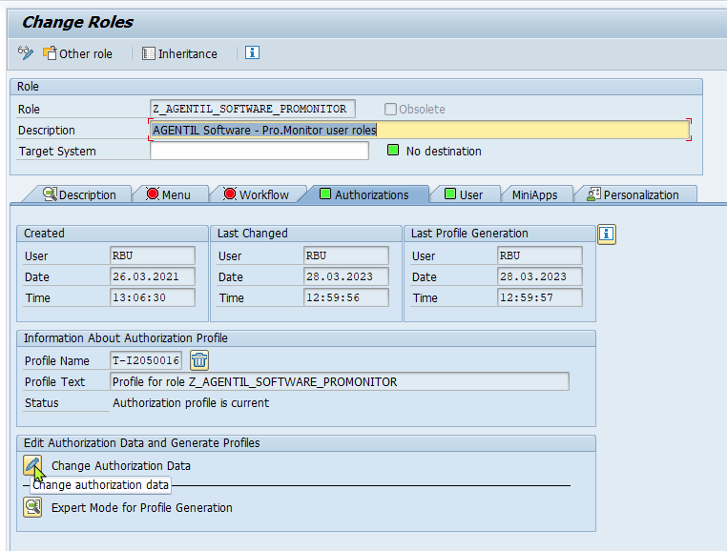
Don't forget to press generate


