Multi instance
- Several Pro.Monitor instances can work together to distribute monitoring workload.
- The instance with central server role will manage the configuration and distribute tasks to the ones with agent role.
- A central server can also act as an agent.
- A standalone Pro.Monitor instance will therefore be a central server and an agent.
- Communication between Server and agents is Unidirectionnal: Only agents will initiate connection to the Server.
- The Server doesn't require any inbound connection to the agent's network.
- The server can therefore be publicly accessible while the agents can be in protected area: No need for SSL tunnel, VPN or complex network settings to deploy a mutli-instance implementation and centrally manage the monitoring of multiple isolated environments.
- This architecture can also be used to add more robustness, by having several monitoring agents and be resilient in case one goes down.

Role settings

- In the Role section, you can configure:
  - Central server role : If active, the instance will centrally manage monitoring configuration
  - Agent: If active, the instance will execute monitoring tasks (connect to systems, detect problems, generate metrics and alerts)
  - Central server URL: The server to bind to.
  - Download and install a certificate
    - Simply click on “Download and install a self-signed certificate” button and Pro.Monitor will perform all necessary operation to have the job done !
    - Be aware of the following :
      - Default certificate will not work in Multi-instance mode, agents will refuse the connection because the certificate is not bound to server IP address
      - In this case, you must generate a self signed certificate and bind it to the local IP
      - Generated certificates will be stored in the keystore
      - Pro.Monitor keystore is located in the certificates/.keystore file of Pro.Monitor install folder
      - ATTENTION : Any change in security settings will be effective only after restarting Pro.Monitor

Standalone server role
- This is the default mode, no specific configuration is required.
- Central server and agent roles are both enabled. In this mode, Pro.Monitor is an agent and a server at the same time.
- The server will manage the configuration, user interface and execute monitoring tasks.
- Every Pro.Monitor instance with an enabled agent has a local agent used to execute monitoring tasks.
- The agent will appear automatically in the list of accepted agents and cannot be deleted.
NOTE: In standalone mode, it is not necessary to assign groups to the local agent. But if you do so, unassigned groups won't be monitored.

Central server role
- In this mode, Pro.Monitor will manage the configuration of the monitoring and distribute tasks to one or several remote agents.
- It will be used as monitoring portal for the users and also hold the database, and connect to the plugins.
- Central server role must be active in the Multi-instance tab
- Central server URL, including scheme and port number must be registered in the Central server URL field of each agent
- Each agent bound to the server must be accepted once by the admin
- Associations between groups and agents must be done via the Agents groups tab.
- One group can be managed by several agents, in that case, group workload will be distributed across each compatible agent.
- Some system settings from central server will be propagated automatically to each agent:
  - Number of parallel tasks
  - Monitoring process timeout
  - Log level and duration
- Most others like Monitoring process memory will still be local settings
- If the Agent role is enabled, the local agent will be used as any remote agents.
NOTE: You can visualize agent activities in the Monitor statistics menu (Must activate monitors results retention in System tab)

Agent role
- In Multi-instance tab, activate Agent mode and deactivate Central server role
- Define the agent name to use
- Set the primary server URL
- Save the settings. The agent will connect to the primary server and will be handled from there.
- Some local settings will still remain available, such as System->monitoring processes memory or log retention
- Connecting to central server in HTTPS:
  - Server must use an certificate generated for its actual IP (will not work will the default certificate)
  - Download server certificate using your browser and add it in the Pro.Monitor keystore of the agent (see HTTPS config for more details)
NOTE:
- If the instance was previously used as a server, its configuration will be hidden until switched back to its server role.
- The Agent doesn't require any licence

Failover
Failover allows to implement high availability for a Pro.Monitor server
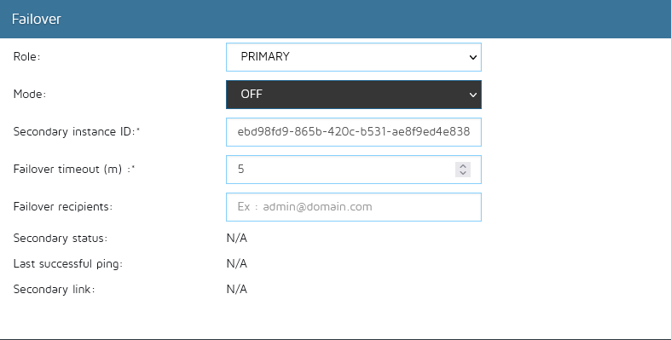
- To implement high availability, one Pro.Monitor instance must be set as PRIMARY and another one as SECONDARY
- Url of the PRIMARY must be registered in the SECONDARY
- Instance UUID of the SECONDARY must be set in the PRIMARY
- PRIMARY must be set to ACTIVE mode
- SECONDARY must be set to STANDBY mode
Once set the following will happen:
- The SECONDARY will regularly poll the PRIMARY and refresh its configuration if anything changed on the PRIMARY.
- The SECONDARY will switch to ACTIVE mode to replace the PRIMARY in two cases:
  - If the SECONDARY cannot reach the PRIMARY after a timeout.
  - If the PRIMARY indicates an inconsistent state to the SECONDARY
To revert from a failover:
- If the PRIMARY becomes online again, the SECONDARY will not switch to STANDBY automatically
- You have to manually set the SECONDARY to STANDBY. DO NOT SWITCH PRIMARY TO ACTIVE I must become active automatically
- If SECONDARY is in STANDBY mode, the PRIMARY will automatically switch to ACTIVE
By default, the failover mode is set to OFF, use this mode to deactivate the failover mechanism.

