Monitor Errors

Purpose
When monitoring a system, errors may occur when monitor jobs are executed.
Pro.Monitor displays which monitor jobs have encountered errors during execution and gives the possibility to the user to inspect
those errors providing detailed information and a filtering function.

To have a global view of monitors activity :
- Click on Systems view tab - on top of the screen - (image 1).
- In the “Monitors” column, the number of executions of a given monitor job is displayed.
- In case that one or more executions have encountered an error, a red number is displayed.
- Clicking on the red number will display a table containing detailed information concerning the monitor error/s (image 2).
- It is possible to filter by Company, System and Connector using their related dropdown lists.
- You can also enter a text on the “Search” text field to find the text among the table columns

image 1
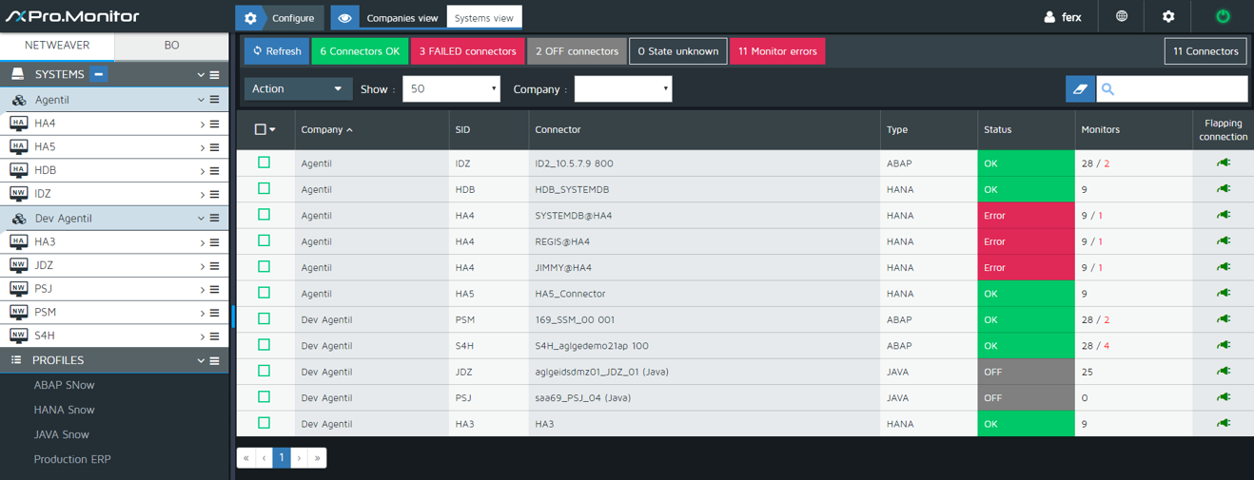

image 2


