Datadog plugin

Purpose
- The Datadog plugins allows to integrate Pro.Monitor with Datadog via its cloud API
- Devices, events and metrics discovered by Pro.Monitor will become visible in Datadog
- Predefined dashboards can be downloaded from Datadog market place on Pro.Monitor's page.

Configuration
- The Datadog plugin will directly connect to your cloud instance by using several API endpoints.
- To configure the plugin, you need to register the parameters below.
- Note: API & Application keys must be generated first on your cloud instance for allowing connection.
Parameter | Description | Example
Name | A name of your choice for the plugin | My Datadog plugin
Host | The datadog API endpoint of your cloud instance: https://api.datadoghq.[com/eu] | https://api.datadoghq.com/
API key | The API key to use to connect to the datadog instance | UUID provided by Datadog
APP key | the APP key to use to connect to the datadog instance | UUID provided by Datadog
Max metrics payload size | The number of metrics to send per API call | 50
Custom tags | A comma separated key:value pairs of tags to systematically associate with metrics and events
Track distinct time series | If enabled, Pro.Monitor will record distinct timeseries (see explanation below) | false
Send alarms | If enabled, Pro.Monitor will send generated alarm to Datadog, visible as events | true
Send metrics | If enabled, Pro.Monitor will send generated metrics to Datadog, visible as metrics | true
Send logs | If enabled, Pro.Monitor will send generated alarm to Datadog, visible as logs | true
 If you want to stop the data flow between Pro.Monitor and Datadog, you can deactivate the plugin.

Datadog API & APP keys
- To create those keys, connect to your datadog instance and open the Organization settings
- Navigate to API keys and Application keys sub menus and create your new keys
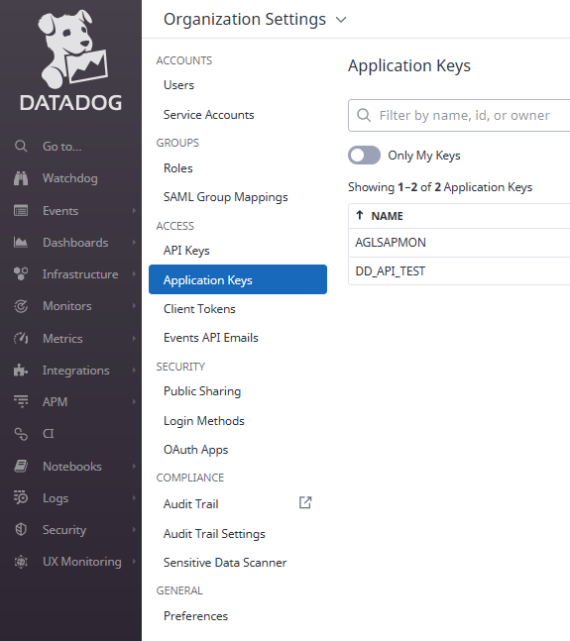

Architecture
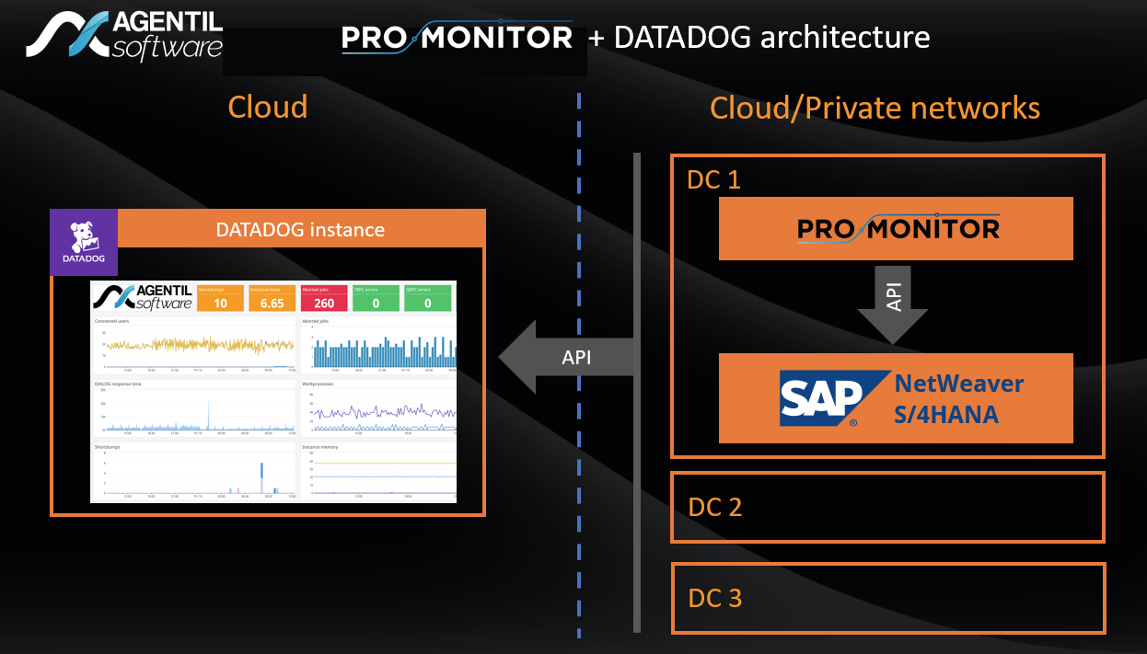

Proxy settings
- To use a proxy for outgoing HTTP and HTTPS connections, edit bin/setenv.sh file from promonitor server
- Add to the JAVA_OPTS variable the following parameters:
  - -Dhttps.proxyPort=<HTTPS proxy port> and -Dhttps.proxyHost=<HTTPS proxy host>
  - -Dhttp.proxyPort=<HTTP proxy port> and -Dhttp.proxyHost=<HTTP proxy host>

Collected data

Events
- All alarms produced by Pro.Monitor will be sent to datadog

Metrics
- All metrics produced by Pro.Monitor will be sent to datadog

Logs
Pro.Monitor is using logs interface to send the following data
SAP jobs
- tags:
  - job_name
  - client
  - status
  - start_date
  - end_date
- Example:
  - Mar 16 09:22:48.000 10.222.2.2 SAP_JOBS name:SAP_COLLECTOR_PERFMON_RSHOSTDB client:000 user: status:FINISHED Start:09:22:48 End:09:22:48
Shortdumps:
- tags:
  - date
  - client
  - user
  - error
  - instance
  - message
- Example:
  - Mar 16 08:00:27.000 10.222.2.2 SAP_SHORTDUMPS instance:saa69_PSM_00 client:001 errorid:DYNPRO_SEND_IN_BACKGROUND report:RLCR_XI_STAYING_ALIVE
System logs
- tags:
  - instance
  - date
  - area
  - program
  - subid
  - user
- Example:
  - aglges4has.agentil.local SAP_SYSLOGS instance:aglges4has_S4H_00 user:BASISJOBS program:RSSNAPDL area:AB subId:D text:Short dump deleted with default tool RSSNAPDL

Distinct time series tracking
- If the tracking is active, the distinct times series sent to Datadog will be recorded
- This gives the possiblility to know how many metrics have been created in datadog
- This also allows to analyze the cardinality of the metrics and fine tune the configuration
- The list of distinct time series can be collected by this HTTP API call:
GET /plugins/statistics/distinct_ts?type=DATADOG

Custom tags
- You can force a set of tags to be always associated to each metric, log and event.
- This can be configured via two ways:
From the plugin menu:
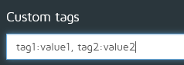
From the properties file:
the file conf/monitoring.properties
- Set the property: plugins.datadog.custom_tags
- Example:
  - plugins.datadog.custom_tags=tag1:val1,tag2:val2
Once set, you must restart Pro.Monitor

