E-mail Plugin

Purpose
- The e-mail plugin gives the possibility to send alarms via e-mail
- Once active, this plugin will collect all generated alerts and send e-mails only if the alert haven’t been already notified by a previous e-mail
- It is possible to define several receivers, receivers in copy and receivers in blind copy.

Configuration
- As a prerequisites, Pro.Monitor has to have access to an SMTP server
- In the Administrator “Plugins” menu item, select Mail type and create the plugin, this will open the plugin configuration screen
- If an e-mail gateway is defined in Pro.Monitor via the admin configuration (Admin Configuration --> Mail gateaway) you can import those settings directly in a plugin by simply clicking on the “Copy mail gateway settings if configured” button (on top of the settings sections) , corresponding fields will then be automatically filled. (see image I)
- Fill the plugin settings form:
  - Enabled: To enable or disable the plugin
  - Name: The name of the plugin to display in the list of plugins
  - Server*: URL to the SMTP server
  - Port*: Port to use to address the server
  - Secure TLS connection*: To set if the server need to communicate via a secure TLS connection
  - Username/Password*: If an authentication to the server is mandatory the credentials can be defined here
  - From: Define the sender’s e-mail address
  - To: Type in this field a receiver e-mail address and hit the add button to add this address the receivers list. To delete a receiver use the delete button
  - Cc: Type in this field a receiver in copy e-mail address and hit the add button to add this address the receivers in copy list. To delete a receiver use the delete button
  - Bcc: Type in this field a receiver in blind copy e-mail address and hit the add button to add this address the receivers in blind copy list. To delete a receiver use the delete button
  - Text or HTML : Define content type mail
  - Subject : Subject email sended
  - Email body : Customize the content email.
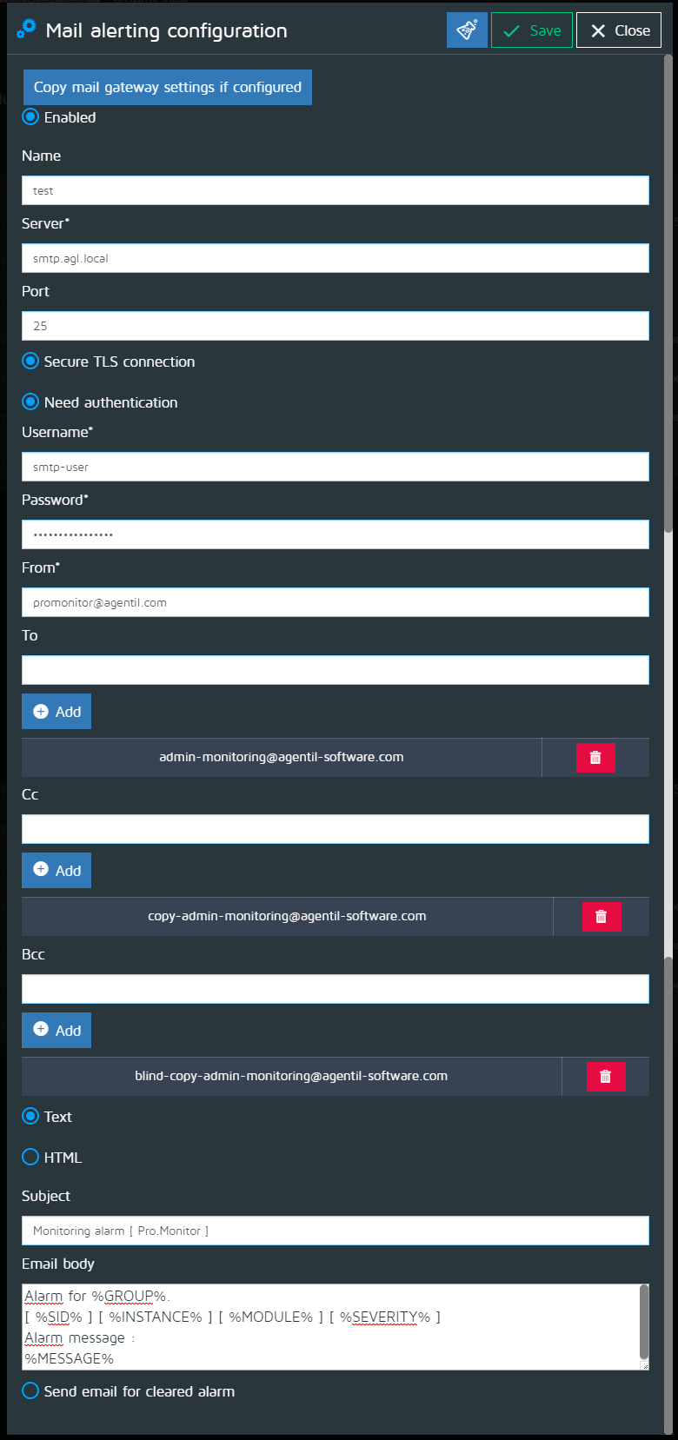
- Notice that you can use the following predefined Pro.Monitor variables along “Subject” and “Email body” fields:
  - %ID% : replaces by the Alarm ID
  - %GROUP% : replaces by the Group (Company) name
  - %SID% : replaces by the System ID (SID)
  - %INSTANCE% : replaces by the Pro.Monitor instance name
  - %SEVERITY% : replaces by the the Alarm severity level
  - %MESSAGE% : replaces by the message sent by the Alarm
  - %MODULE% : replaces by the Alarm module
  - %TO_CLEAR% : replaces by “true” or “false” depending on if the Alarm is to be cleared or not
  - %CLEARABLE% : replaces by “true” or “false” depending on if the Alarm is a “can-be-cleared” type or not
  - %COMPONENT% : replaces by the Alarm component (i.e. “disk”)
  - %STACK% : replaces by the alarm stack type
  - %ALARM_TAG% : replaces by the description of the alarm tag
  - %CLEARED% : replaces by “CLEARED” if the Alarn has been already cleared or “” (none) if not
  - %COUNT% : replaces by alarm counter
  - %AGENT% : replaces by the Agent UUID (Pro.Monitor internal Agent unique identifier code)
  - %SAMPLE_RATE% : replaces by the monitor sample rate as per execution schedule
  - %RULE_NAME% : replaces by the name of the rule matched by the alarm, if any
  - %RULE_DESCRIPTION% : replaces by the description of the rule matched by the alarm, if any
  - %TIMESTAMP% : replaces by the formatted timestamp of the Alarm in local timezone
  - %TIMESTAMP_UNIX% : replaces by the unformatted timestamp of the Alarm in UNIX epoch format (milliseconds since January 1st 1970)
  - %TIMESTAMP_XXX% : replaces by the formatted timestamp of the Alarm using specified timezone (XXX):
    - Example: %TIMESTAMP_UTC

