Google Cloud Logging plugin

Purpose
- The GCL plugins allows to integrate Pro.Monitor with Google Cloud Logging
- Monitoring data discovered by Pro.Monitor will become visible in Google Cloud Logging as logs

Configuration
- The Google Cloud Logging plugin will directly connect to your cloud instance by Google API endpoints.
- To configure the plugin, you need to register the parameters below.
- Note: Service Accounts & key must be generated first on your IAM & Admin for allowing connection (see Service account & keys section below)
- Also, make sure Google API & services are enabled
Parameter | Description | Example
Name | A name of your choice for the plugin | My Google Cloud Logging
Project id | The Google Project id | semiotic-karma-384208
JSON authentication key | JSON authentication key to use to connect to the Google Cloud Logging | provided by Google
Monitored resource type | Monitored resource types used in the Logging API | GCS Bucket OR Cloud Pub/Sub Subscription
Other parameters following the Monitored resource types can be needed
GCS Bucket
Parameter | Description | Example
project_id | The identifier of the GCP project associated with this resource, such as “my-project”
bucket_name | An immutable name of the bucket | false
location | Location of the bucket | false
Cloud Pub/Sub Subscription
Parameter | Description | Example
project_id | The identifier of the GCP project associated with this resource, such as “my-project”
subscription_id | The identifier of the subscription, such as “my-subscription”.
Google documentation : https://cloud.google.com/logging/docs/api/v2/resource-list#resource-types

Service account & keys
- To create those keys, connect to your IAM & Admin and open the Service Accounts
- Click on CREATE SERVICE ACCOUNT
- Add the role Logs Writer
- Generate the JSON key
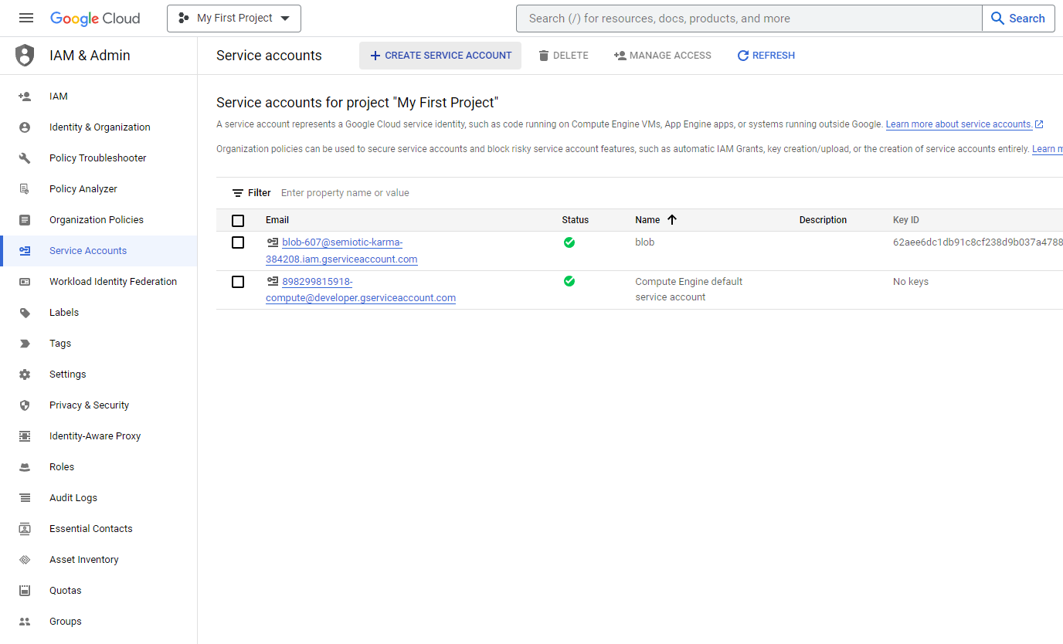
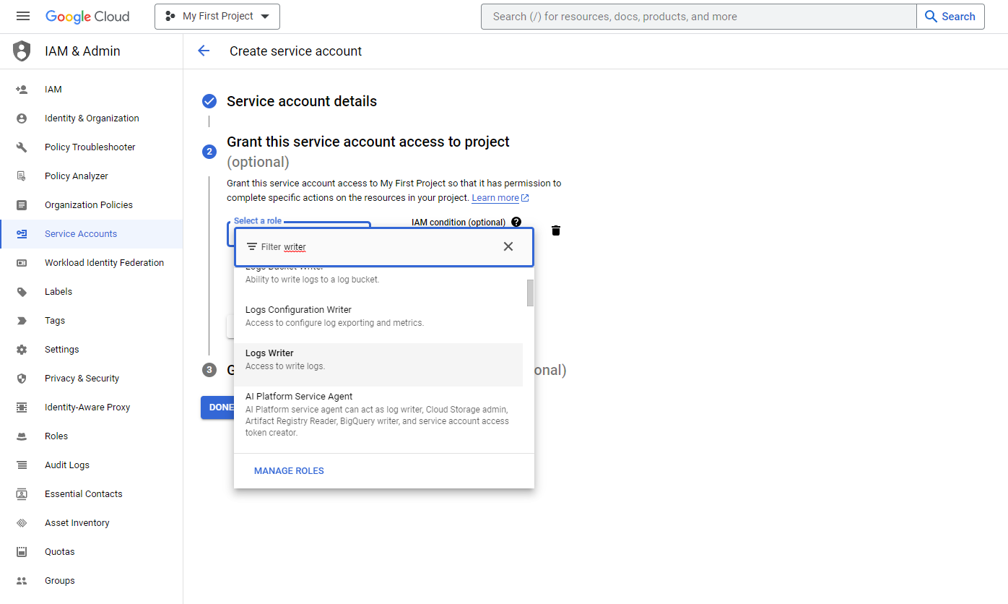
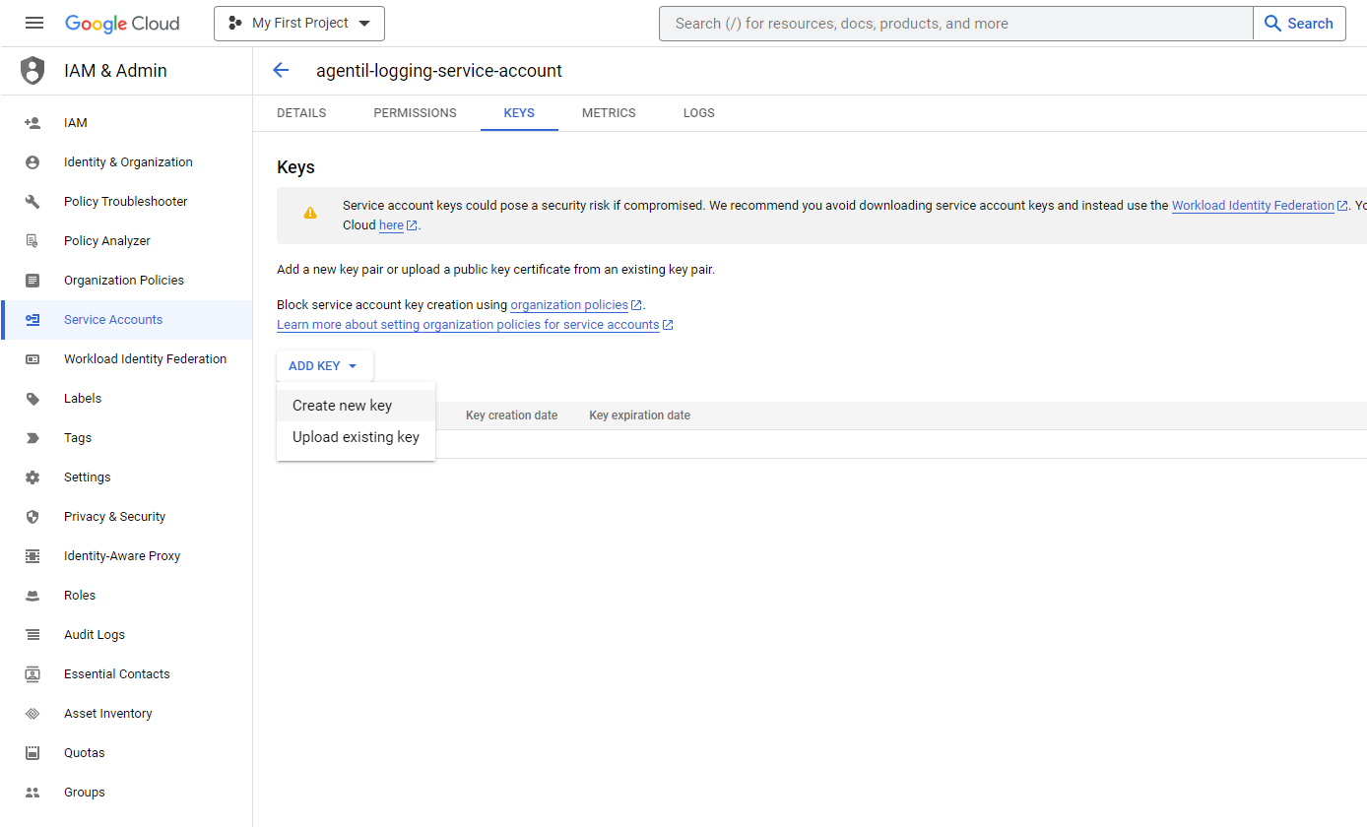
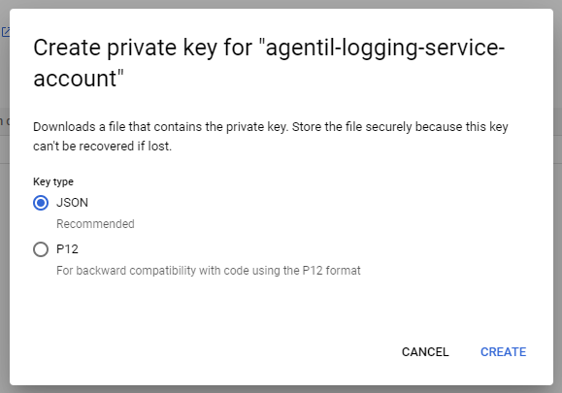

Logs
Pro.Monitor is using logs interface to send the following data
SAP jobs
- tags:
  - job_name
  - client
  - status
  - start_date
  - end_date
- Example:
  - Mar 16 09:22:48.000 10.222.2.2 SAP_JOBS name:SAP_COLLECTOR_PERFMON_RSHOSTDB client:000 user: status:FINISHED Start:09:22:48 End:09:22:48
Shortdumps:
- tags:
  - date
  - client
  - user
  - error
  - instance
  - message
- Example:
  - Mar 16 08:00:27.000 10.222.2.2 SAP_SHORTDUMPS instance:saa69_PSM_00 client:001 errorid:DYNPRO_SEND_IN_BACKGROUND report:RLCR_XI_STAYING_ALIVE
System logs
- tags:
  - instance
  - date
  - area
  - program
  - subid
  - user
- Example:
  - aglges4has.agentil.local SAP_SYSLOGS instance:aglges4has_S4H_00 user:BASISJOBS program:RSSNAPDL area:AB subId:D text:Short dump deleted with default tool RSSNAPDL

