4. HANA connector

Purpose
- With the HANA DB connector, you can collect information directly from the database itself:
- All statistics data (service status, CPU, disk, memory, threads, connections, etc…),HANA alerts, Performance statistics and more
- Unlike other systems, HANA connectors will be created automatically based on system settings
- This connector uses a direct SQL connection in the database
- To create HANA connector, there are two steps:
  - Create a DB user and register it in Pro.Monitor
  - Edit the HANA system and register connection
- Note: You must install HANA ngdbc.jar driver if you want to connect to a HANA database

Create user profile
- User profiles can be reached via Systems->SAP users
- Create a new profile using the “Add” button
- Once created, the user profile can be selected in the connector form
- Note: A user profile is by default associated with a company . You can explicitly set a profile to be cross companies. The effect is that it will be selectable from connectors of any companies.
- The corresponding user must be created in the database and must be granted with MONITORING role

Create connector
- From a group contextual menu, select Add HANA system
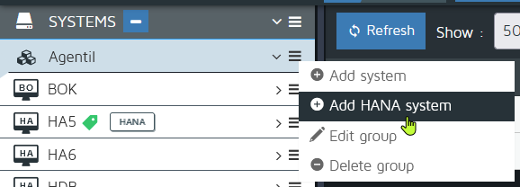
- Set common parameters:
  - System ID:SAP System Id (up to 3 characters)
  - Instance number: Main instance number
  - Description: SAP system description
- In the Nodes section (tab):
  - Define the hostnames of the nodes of the system (can be multiple in case of s scale-out system)
- In the Databases section (tab):
  - Define the tenants that you want to monitor:
  - Notice that one connector per tenant will be created

- Title: the display name of the tenant
- Tenant: the tenant name in the DB
- Default port: If active, will compute the tenant’s port based on its system number
- SQL port: The custom port if default port if disabled.
- User: The user profile to use for the connection
- Secure: To enable if secure connection is going to be used
- Primary: To enable if the system is replicated and is a primary node.

Custom timeout
- See Custom timeouts

