

SL1 integration

Architecture
- To visualize SAP monitoring data in your ScienceLogic SL1 instance, you need to install a Pro.Monitor collector in each data center hosting the systems.
- Pro.Monitor will act as a proxy between your SAP systems and a ScienceLogic SL1 collector
- It will connect remotely to each SAP system and needs to be installed in a network area allowing to do so
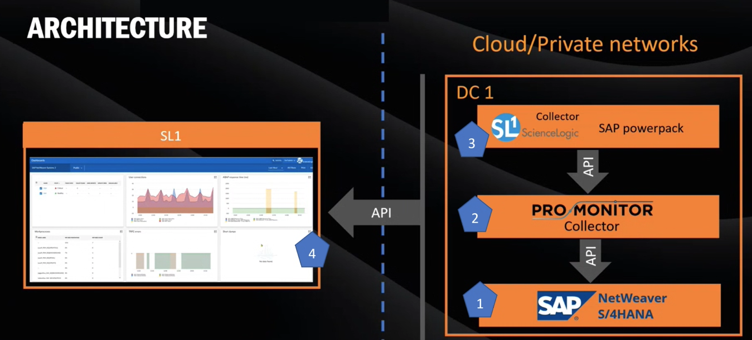

Skills
- Those responsible for installing the solution should have the following skills:
  - Basic linux administration for installing software and creating user accounts
  - SAP basis users & authorizations administration
  - Database users administration
  - Network administration to implement network routes
  - SL1 administrator for installing collector and configuring the powerpack

Prerequisites
- A Pro.Monitor license, requested at support@agentil-software.com.
- A dedicated Linux VM with appropriate specs
- Network routes open toward SAP application ports
- A dedicated user created on each system to monitor (See create SAP users)
- See AGENTIL's Pro.Monitor Prerequisites Documentation for more details.

Installation
Insalling and configuring Pro.Monitor should not take more than an hour if prerequisites are set correctly
- Install the JAVA JRE
- Download the latest Pro.Monitor package.
- Copy the package into a temporary folder - Not in /opt
- Execute below commands:
tar -zxvf [PACKAGE FILE NAME]
./install.sh
systemctl start promonitor
- Pro.Monitor should be up and running.

Configuration
You can configure Pro.Monitor using a web interface:
- Visit http://[PRO.MONITOR VM HOSTNAME]:8888 in a web browser. The default username/password combination is admin/admin

Install license
- Click the gear icon on the top right to open a menu. Then, select Licenses.
- Copy the provided license keys and save

Install drivers
- Get the latest SAP JCO driver for Linux and unzip the file to extract a tgz archive.
- Click the gear icon on the top right to open a menu. Then, select Admin configuration and go the Upload/Download section.
- Click on Install JCO driver and select the driver file (file name similar to sapjco30P_17-10005328_linux.tgz).
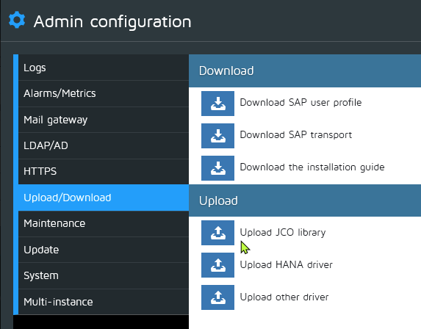

Connection to ScienceLogic SL1
- The SL1 collector will pull data from Pro.Monitor API to discover SAP environement and collect SAP metadata.
- You just need to create a Generic event server to activate the API
- Click the gear icon on the top right to open a menu. Then, select Plugins.
- Select the Generic server type in the plugin selector and press create.
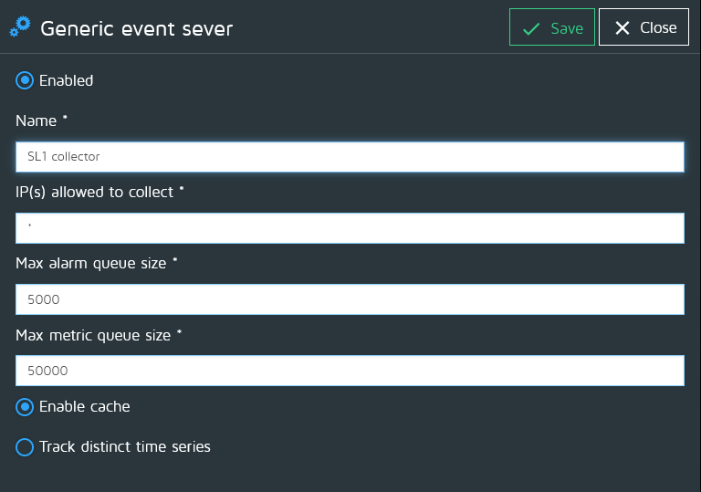

Connection to SAP
For connecting Pro.Monitor to a SAP system, you will need first to create a group, a system, a user and a connector.
- Create your first group
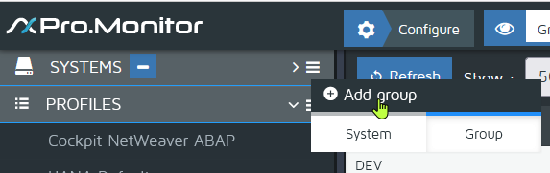
- Fill the group formular
- Don't foget to set group shortname and company shortname:
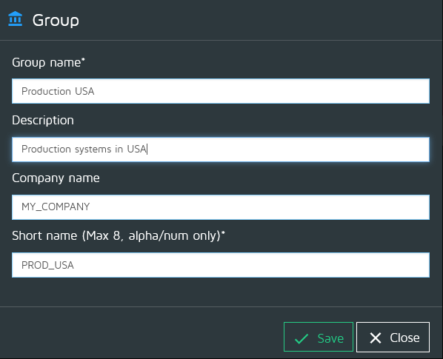
- You can now create your first system
- From the group contextual menu, select “Add system”
- Select the appropriate system
- Don't forget to set system shortname
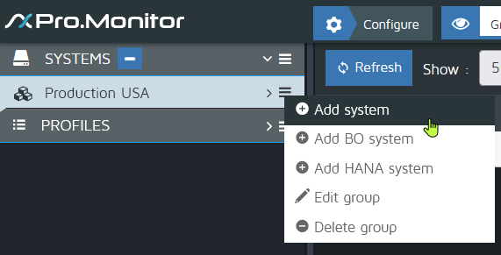
- Now you can create a user
- From configure menu, select add user
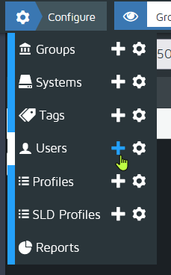
- User profiles are associated to a group
- It will be used later when creating a connector
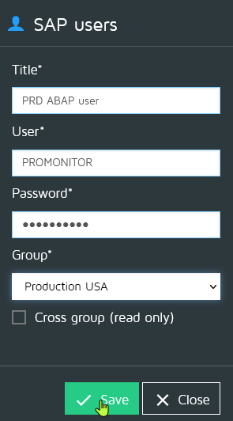
- Now you can create connector
- From the system contextual menu, select “Add connector”
- Select the appropriate connector type
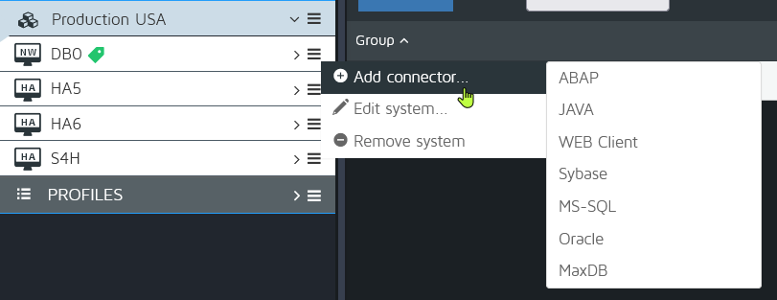
- Then fill the connector form
- The connector holds the necessary connection parameters to reach the system
- Press Save&Test, you should see a green popup indicating a successful connection
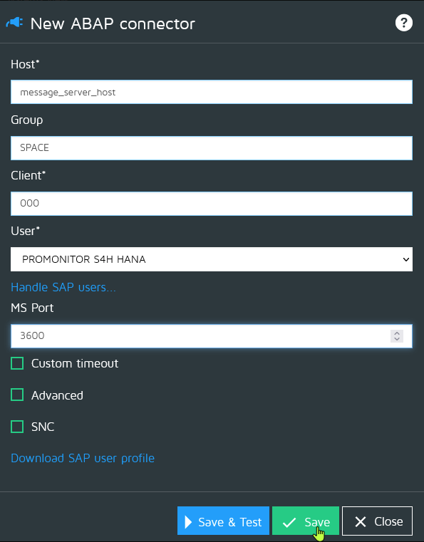

Configure monitoring
The monitoring of SAP systems is done via monitoring profiles
- Create your first profile
- You can import, create and customize profiles from the profiles section on the left
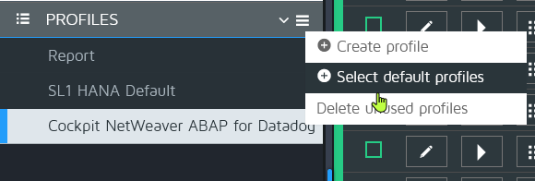
- From the profiles menu, select Select default profiles
- Select the ScienceLogic SL1 profile and press Save.
- The imported profile will appear in the list of profiles
- Now you can assign your profile via the assign button
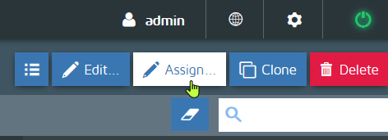
- From the assign menu, just move the available connectors from right to left, then save.
- Your connectors are now associated with a set of predefined monitors
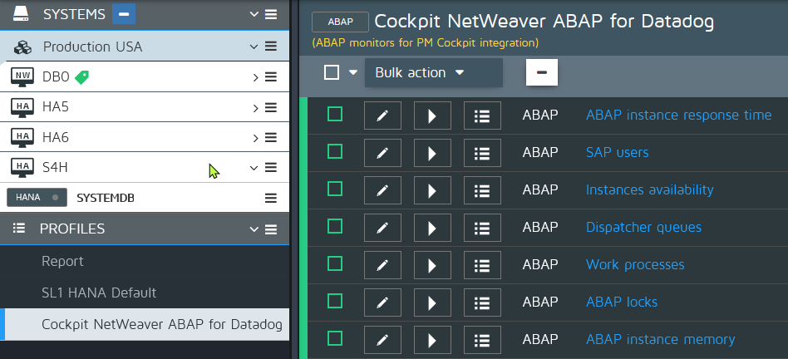
- Last step: Activate the monitoring:
- Select a connector and press “Start monitoring”
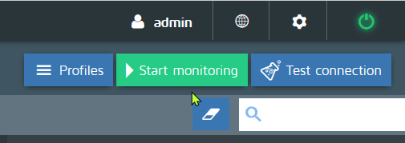
Monitoring is now active for all your systems, which you should see in ScienceLogic SL1.

ScienceLogic SL1 configuration
- Powerpack installation guide

Support
For support or feature requests, contact AGENTIL Software at support@agentil-software.com

