Create users

ABAP system
- In order to monitor an ABAP system, a dedicated user must be created in SAP and registered in Redpeaks
- All the accesses performed in the system will be made on the behalf of this user
- This user must have appropriate authorizations to grant access to the components that needs to be monitored
- Via the PFCG transaction, you can import this profile in SAP
- You can download a predefined authorization profile from Admin menu->Admin configuration->Upload/Download->Download SAP user profile
- Create the user in SAP via SU01 transaction and associate it with the uploaded profile:
  - It must be a communication user
- Following default settings must be used :
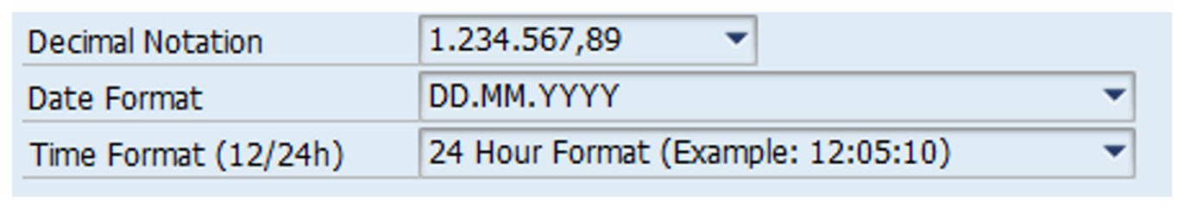
- Important Note: For “Cross clients” monitors, it is advised to use a connector to client 000 only.
  - However, you might want to connect to production clients to cover non “Cross clients” monitors.
- Once the SAP user is created, you can register it in Redpeaks. From the left side screen, open the menu of SYSTEMS tab, click on SAP USERS, then ADD

JAVA system
- In order to monitor a JAVA stack system, Redpeaks uses SAPControl web services.
- If the mandatory services are protected, Redpeaks will need a dedicated OS user with admin privileges (like [SID]adm)
- See SapControl connector setup for more information

HANA system
- In order to monitor a HANA database, we need an SQL user associated with MONITORING authorization

SAP ASE (Sybase) databases
- Sybase connector uses JDBC to connect to the database and executes SQL queries to inquire the DB
- SQL user associated to the database connector needs all necessary rigths granted to proper monitor the system
- Visit SAP ASE connector for detailed information

