Custom IDOC segment collector
Describes how to install, activate and use the Third Party Component tools developed to read IDOC segments into an SAP ERP

Install transport

Prerequisites
- The new custom Function Module ZIDOC_PARSE has been created and is stored in a workbench transport request PSMK900288
- Download the transport file from Redpeaks collector Settings->Admin configuration->Upload/Download
- Unzip the archive and upload the 2 files in the target system using CG3Z transaction:
R900288.PSM | K900288.PSM
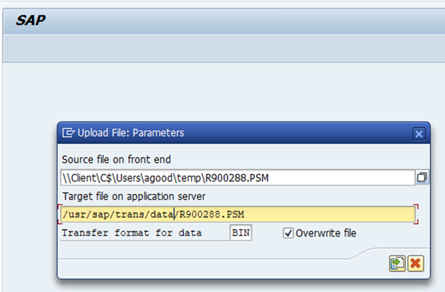 | 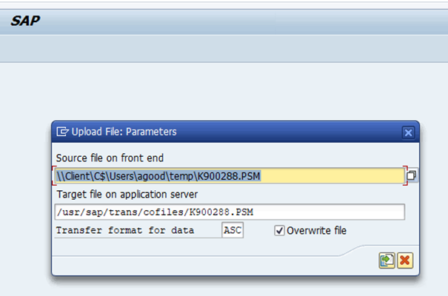

Import the new FM ZIDOC_MONITOR with STMS
- Execute STMS transaction to open transport management, the follow the procedure:
- Select target environment
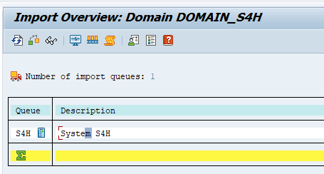
- Upload the transport request into the target environment
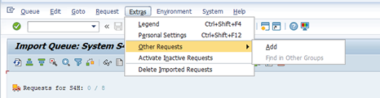
- Select imported Cofiles
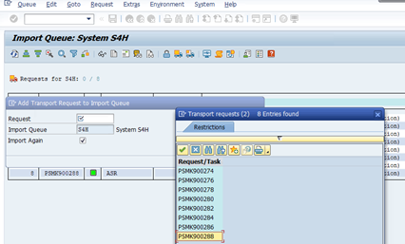
- Press ok to trigger the upload
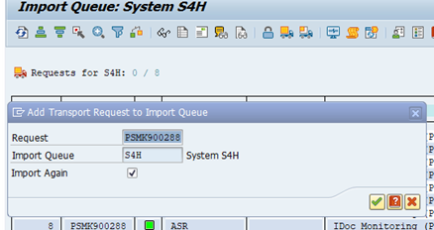
- The request is now available for the actual import
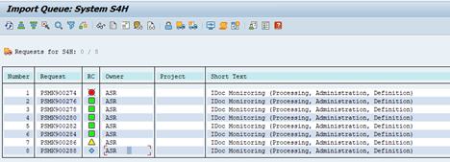
- There can be a version discrepancy between the source and target system, select ignore install component version and continue
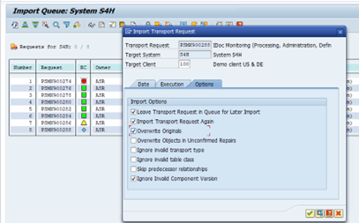 |

Content of the transport
- Once the STMS import finished two new custom Function Modules will be added:
  - ZIDOC_READ_COMPLETELY : A duplicate of IDOC_READ_COMPLETELY, tuned for our needs (to read only necessary data).
  - ZIDOC_PARSE, a function module designed to read a selection of IDOC segment data, regardless of system version (4,3,old)

ZIDOC_PARSE
- ZIDOC_PARSE is a wrapper for ZIDOC_READ_COMPLETELY allowing to read selected IDoc segment properties.
- Input Parameters:
  - NUMBER_OF_DATA_RECORDS : Allows to limit the number of returned results.
  - ZTIDOC_PARSE : A table for setting Idoc numbers, segments and field names to read
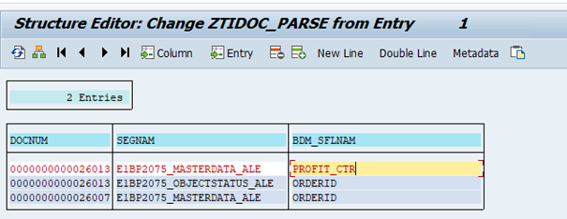
- Output parameter
  - ZTIDOC_QUERY: A table containing the requested segment data


