SAP Cloud Connector Monitoring
The SAP Cloud Connector includes an API for monitoring purposes. To begin monitoring your cloud connector,
utilize a Redpeaks web service connector along with its specialized monitors.

Prerequisites
- Basic Authentication or Form-based Authentication is required to access monitoring data via the API.
- Ensure users are assigned the sccmonitoring or sccadmin roles.
- For detailed SAP documentation, refer to the official guide

Connector Setup
- Create and configure a Cloud Connector connector to connect to Cloud connector API

Monitoring
- Create a monitoring profile of type WEB_SERVICE
- Amongst the available compatible monitors, choose the Cloud connector type
- You can then edit the monitor and start configuring the monitoring
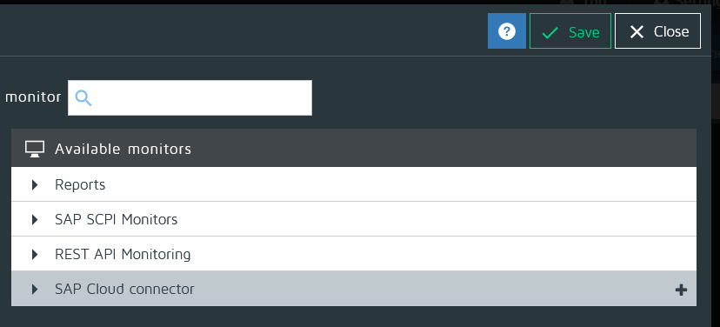

Monitors for SAP Cloud connector
- Subaccount status/connection and certificates
- Virtual memory
- Physical memory
- Heap memory usage
- Disk status
- CPU usage

