Change Tracking

Purpose
- Redpeaks keeps trace of all relevant changes that have been made on the application (updating a profil data, a system data, etc.)
- Significant user activities, such as deleting a system, downloading a configuration snapshot, etc. are also traced
- Administrators are able to see all those changes clicking on Change tracking tab. (image 1).
- It is possible to filter by Company, System, Type, Family and Object name using their related dropdown lists
- You can type a text on the text field to find the text.
- Clicking on the inspection icon will display a list of all fileds that have been changed as well as their before and after change values (see image 2).

image 1
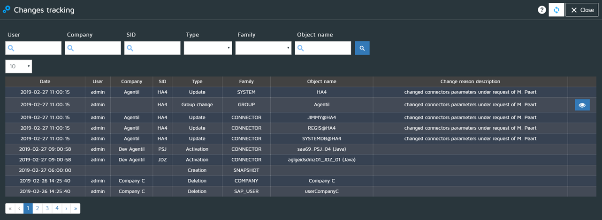

image 2


