Monitor statistics

Purpose
- To access this feature : Go to Adminstrator Settings (gear icon, top-right of the main screen), click on “Monitor statistics” menu option
- This functionality allows the user to inspect all monitor batchs jobs and easily get a situation breakdown.
- It is an usefull tool to supervise all agents workload

Batch view
- For every executed batch, which will group a given number of monitor jobs (see next section for details), Redpeaks will display a table row.
- As shown in the below image, on each row you will find :
  - Batch start/end time and its total (all monitor jobs included) execution time (duration column)
  - The Redpeaks agent that asked to launch the batch
  - The number of jobs composing the batch (number of jobs columns)
  - Those that have been actually executed - not rescheduled - (Executed column)
  - Jobs that has been killed by the system (Killed column)
  - Those that have successfully terminated (Succeeded column)
  - The number of jobs that have been aborted by the system (Aborted column)
  - Jobs that have encountered errors or warnings during their execution will be displayed in Finished with errors and Finished with warnings columns
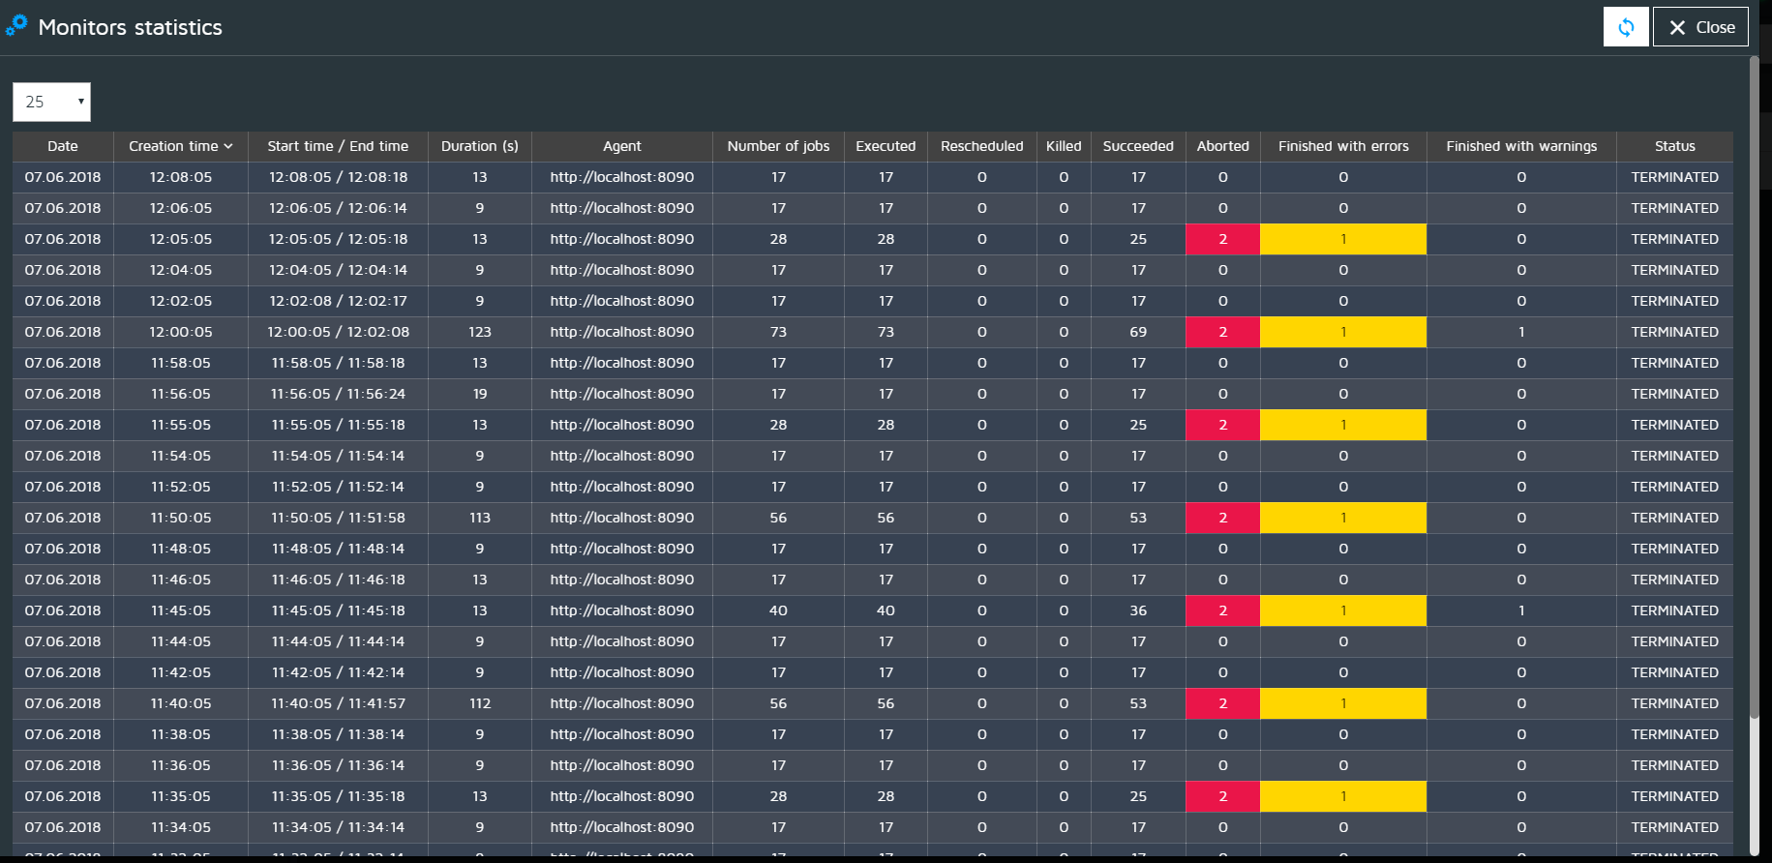

Details of monitor statistics screen
- Clicking on a Monitor Statitistics main table row (see previous section) will open a screen having relevant information about every single monitor job that compose a given batch job, as shown in the image below
- Use left dropdown list to select the number of rows to be displayed on the screen.
- Status dropdown list will display only jobs having a particular status
- Enter a text in Job name text input field to quick search for a particular job name
- Enter a text in Connector name text input field to quick search for jobs related to a specific connector
- Table rows contains, among other information :
  - Elapsed time between the moment that the job has been initially scheduled and the time the job result data has been received (Scheduled / Result received column)
  - Milliseconds precision time the job has been waiting on execution queue (Queue time)
  - Time (expressed in milliseconds) needed by Redpeaks to gather all necessary data to prepare the job result report (Collection time column)
  - Number of Alarms and Metrics sent by the job execution (Alarms and Metrics columns).
  - warnings and Errors encountered during the execution of the job (see next section for details)
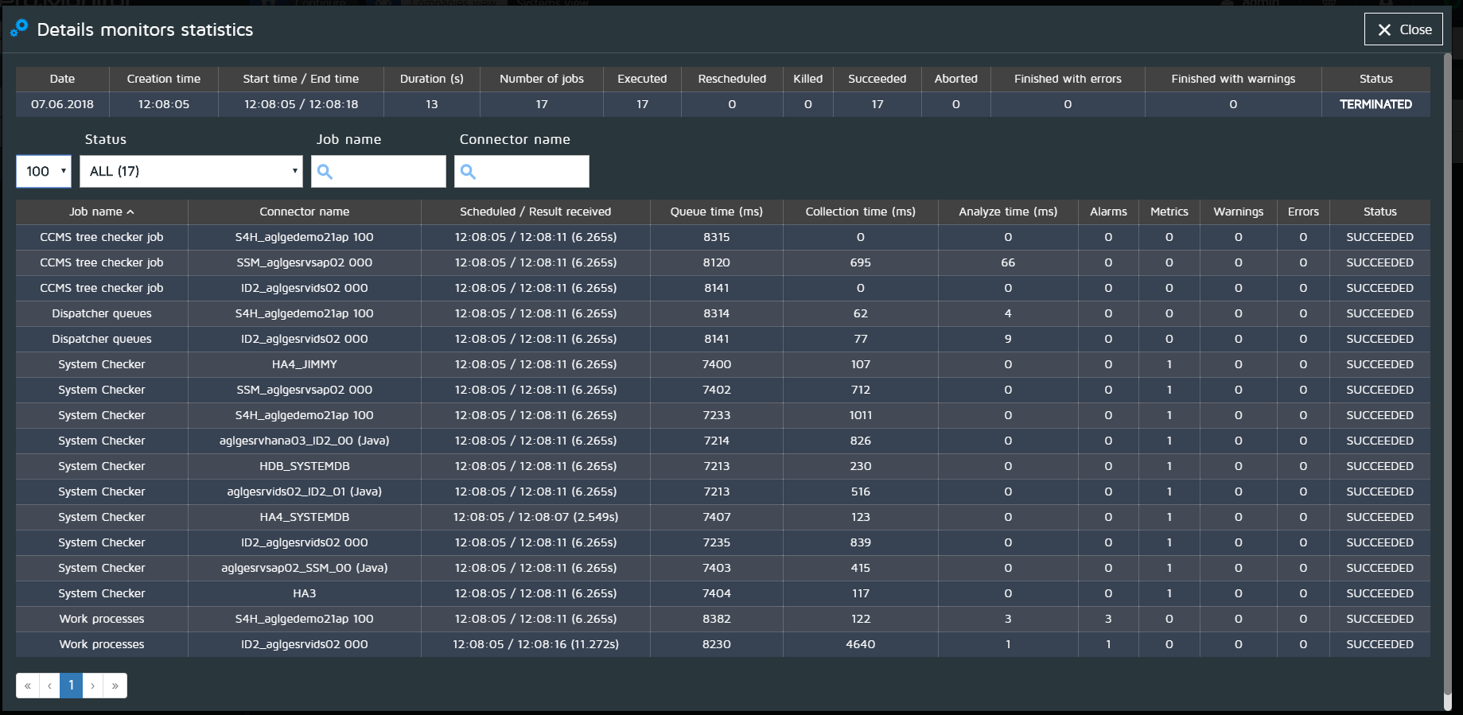

Monitor view
This view allows to look for a particular monitor and get a breakdown of its executions. Use the filters to narrow down according to:
- Agent
- Group
- System
- Connector
- Monitor
- Monitor status
Just click on a monitor's row to display its details
Examples:
- Display all FAILED monitors for a given system
- Display all Short Dumps monitor results for a given Group
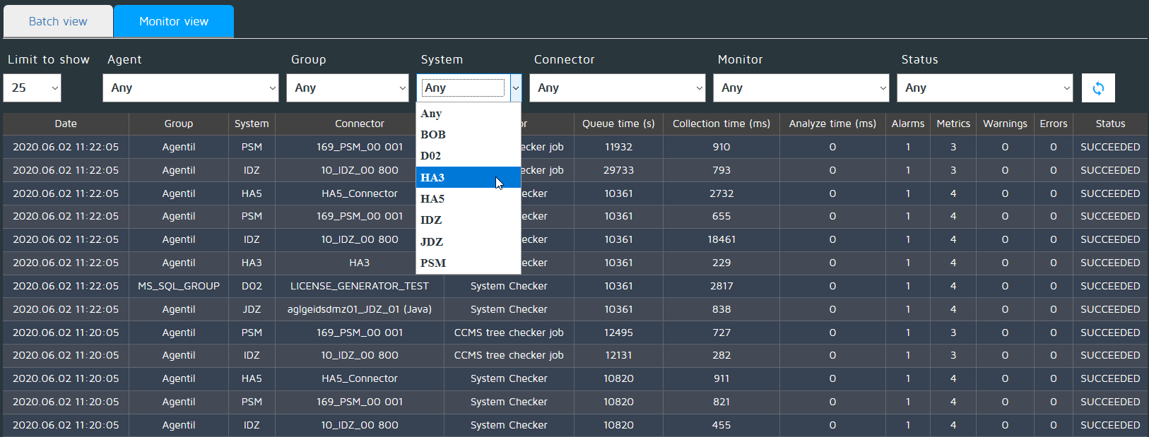

Job details screen
- Pro.Monior supplies the user with a third drilldown level by clicking on any Details of monitor statistics table row (see previous section)
- Detailed information coming from all Alarms and/or Metrics (depending on job) as well as Errors and Warnings the job might have encountered during its execution will be displayed (see image below)


