ABAP connector

Purpose
- With an ABAP connector, you can connect to a system via the message server or via one of the application server.
- Only one ABAP connector is necessary to monitor a whole ABAP system. It will give access to all components that can be monitored by the ABAP monitors
- To create connector, there are two steps:
  - Create a user profile in SAP and register it in Redpeaks
  - Create and set connector parameters
- Redpeaks will use RFC protocol to connect to the ABAP stack
- Note: It is mandatory to install SAP JCO library if you want to connect to an ABAP stack syste

Create user profile
- User profiles can be reached via Systems-> SAP users
- Once created, the user profile can be selected in the connector form
- Note: A user profile is by default associated with a company . You can explicitly set a profile to be cross companies. The effect is that it will be selectable from connectors of any companies.
- The corresponding user must be created in SAP as well with the appropriate authorizations
- Use SU01 and PFCG transactions
  - Download the authorization profile in Admin->Admin configurartion->Upload/Download
  - From PFCG, use Role->Upload to install the profile
  - Important: Edit profile authorization data and press Generate
  - Use SU01 to create the user and assign it to the authorization profile

Create connector
- Select the system in the Systems tree and choose “Add connector” from its contextual menu, then select the ABAP type.
- The default ABAP connector form will allow you to configure a connection to the message server.
  - Host: the hostname or IP address of the ABAP message server
  - Secondary Host the secondary hostname or IP address for failover, separated by a semicolon (;)
  - Group: the logon group (can be set to SPACE by default)
  - Client: The client to which you want to connect (We suggest 000)
  - User: The user profile to use for the connection
  - MS Port: The port of the message server (Usually 36XX): You can use SMMS transaction to find message server port number
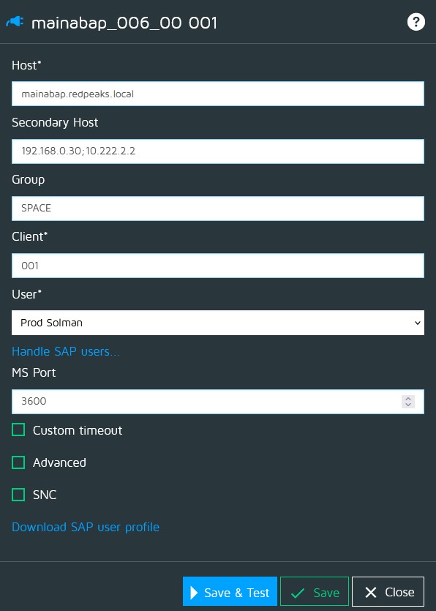

Custom timeout
- See Custom timeouts

Advanced settings
Use advanced settings to use alternate connection method or parameters:
- SAP router: If the connection requires to use a SAP router, you can set it here.
- Gateway host and port: To specify a gateway
  - GW host: Host name of the SAP gateway
  - GW port: Service name of the SAP gateway
- TP name & host: To use an external RFC server.
  - TP Name: Path and name of the external RFC server program, or program ID of a registered RFC server program
  - TP host: Host name of the external RFC server program
- Force connection on AS number
  - Activate this setting when you cannot connect via the message server.
  - Set the mumber of the application server (AS) you want to connect (and use AS hostname as connector hostname)
  - With this method, the connection will always happen on the same AS
- Force Application server IPs
  - Some monitors will connect on each application server for collecting its data. It will use discovered AS hostnames for the connection.
  - In some cases, the hostnames from those AS cannot be resolved from the Redpeaks server.
  - In that case, you can force to use a specific IP for each AS, instead of its discovered hostname.
  - In this setting, you can associate one IP per application server
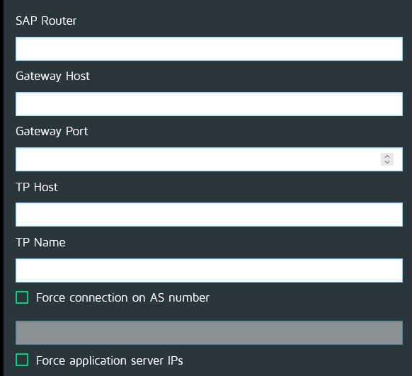

SNC connection
- SNC lib path: Full path and name of third-party security library that provides secure network connection service.
- Partner name: Secure network connection name of the application server (for example, p:CN=R3, O=XYZ-INC, C=EN)
- SNC my name: Indicates the secure network connection name. This property overrides the default secure network connection partner. Token or identifier representing the external RFC program
- More details about SNC
Press Save & Test to save the profile and check the connection is working

