BTP connector

Create BTP Connector
- + Add Connector -> Web Service
- URL -> API Url from the BTP Space e.g.: https://api.cf.eu10-123.hana.ondemand.com
- Authentication type -> SAP_BTP
- User -> Handle SAP users -> Add:
  - Title -> BTP User
  - User -> the user with authorization to access BTP, usually it's an email
  - Password -> password for that user
  - Group
- Select user
- Save and test
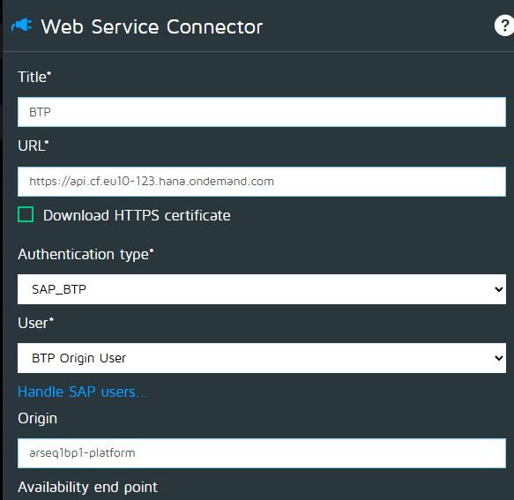

BTP Monitors
- BTP Application Stats Monitor

