SAP Cloud connector
Use this connector to monitor your SAP Cloud connector. It will connect via its REST API interface,
allowing to monitor the different exposed components

Prerequisites
- You must use Basic Authentication or form field authentication to read the monitoring data via API.
- Users must be assigned to the roles sccmonitoring or sccadmin

Monitoring
- A dedicated monitor is available for cloud connector: See SAP Cloud connector monitors page.

Configuration
- Create a Webservice connector and fill the formular:
Parameter | Description
Title | The display name of the connector
URL | The base URL of the web service (example : https://scchost:sccport)
Authentication type | Select BASIC or FORM such as authentication type
User | The user credentials to use to call API
Availability end point | The API used to validate that cloud connector monitor is responding (You can use /exposed?action=ping)

Authentication method
Method | Description
NONE | Connect without authentication
BASIC | Do a basic authentication using the provided user profile
TOKEN | Do an authentication with a Bearer Token, you must set the tocken field
HEADERS | Authentication by headers: Set the header key=value to use in the properties
OAUTH2_CLIENT_CREDENTIALS | Use OAUTH2 and authenticate to token server with a clientId/secret pair
OAUTH2_PASSWORD_CREDENTIALS | Use OAUTH2 and authenticate to token server with the user/password pair of the assigned user profile
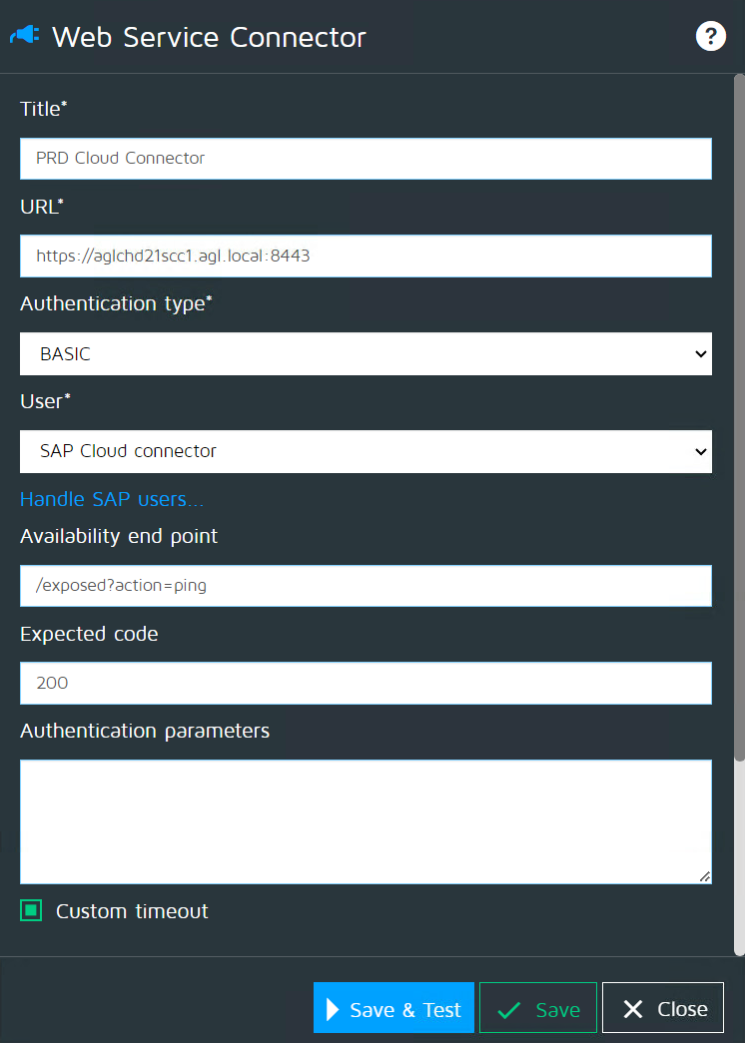

Availability metric
- The metric used to set connector availability is “webservice_availability”.
- It will be set to 1 if the connector successfully connects to the availability end point. It will be set to 0 otherwise.

Other metrics
- More details on SAP Cloud connector page.

Custom timeout
- See Custom timeouts

