SAPControl connector

Purpose
- With the SAP control connector, you can collect information available through the SAP management console for ABAP and JAVA stack systems:
  - Running processes and services
  - Active components
  - Published server metrics and alerts
- This connector uses the SAPControl web services available on each instance
- One connector per monitored application server can be necessary
- To create connector, there are two steps:
  - Create an OS user and register it in Redpeaks
  - Create and set connector parameters

Create user profile

In Redpeaks
- User profiles can be reached via Systems->SAP users
- Create a new profile using the “Add” button
- Once created, the user profile can be selected in the connector form
- Note: A user profile is by default associated with a company . You can explicitly set a profile to be cross companies. The effect is that it will be selectable from connectors of any companies.

In SAP
- The corresponding user must be created in the server at OS level, and associated with the appropriate user group in order to have the authorization to execute the webservices
- You have basically two possibilities:
  - Use an admin user ([SID]adm), to access to the SAPControl web services using authentication
  - Unprotect some of the necessary methods so it can be accessed without authentication. This can be done in the SAP profile of the sapstartsrv using the service/protectedwebmethods argument.
- See Note 927637 for more information.
- Redpeaks will need to access the following methods:
  - Mandatory:
    - GetVersionInfo
    - GetAlertTree
    - GetAlerts
    - J2EEGetComponentList
    - J2EEGetProcessList
    - GetProcessList
    - GetSystemInstanceList
  - Optional:
    - GetEnvironment
    - GetQueueStatistic
    - GetInstanceProperties
    - ListDeveloperTraces
    - ListLogFiles
    - ABAPReadSyslog
    - ABAPReadRawSyslog
    - ABAPGetWPTable
    - J2EEGetThreadList
    - J2EEGetSessionList
    - J2EEGetCacheStatistic
    - J2EEGetApplicationAliasList
    - J2EEGetVMGCHistory
    - J2EEGetVMHeapInfo
    - ReadDeveloperTrace
    - GetStartProfile
    - GetTraceFile

Create connector
- Select the system in the Systems tree and select “Add connector” in its contextual menu, choose ABAP type.
- The default ABAP connector form will let you configure a connection to the message server.
  - Host: the hostname or IP address of the ABAP message server
  - System number: The system number of the application server, this will define connection ports: 5XX13 or 5XX14 if secure mode is on.
  - User: The user profile to use for the connection. Leave empty if no authentication will be used.
  - Force connection port: To use if the port of the service is different than 5XX13 or 5XX14
- Press Save & Test to save the profile and check the connection is working
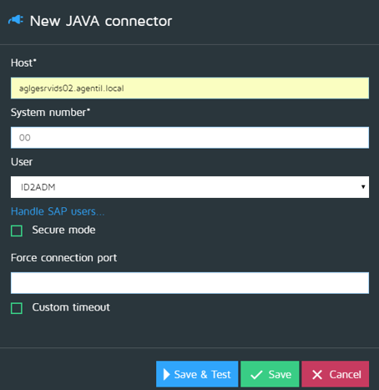

Custom timeout
- See Custom timeouts

