Web client connector
This connector will give access to the administration portal. It can be used to check that the portal
is responding and also to collect and analyze information from any of its sections

Create user profile
- User profiles can be reached via Systems-> SAP users
- Once created, the user profile can be selected in the connector form
- Note: A user profile is by default associated with a company . You can explicitly set a profile to be cross companies. The effect is that it will be selectable from connectors of any companies
- Create the corresponding user in SAP in order to have access to the portal

User authorizations
In case of the user management engine (UME) referred to a data source served by an ABAP client stack, the user account to access PI/XI information in the web portal must meet the following prerequisites:
- The web client connection user must be created in the client of the UME associated ABAP system (normally it is the “production” client, ask to the users administrator).
- Following roles must be granted to the user: SAP_XI_DISPLAY_USER_J2EE, SAP_XI_RWB_SERV_USER (exclusively, DO NOT USE A COPY)

Create connector
- Select the system in the Systems tree and select “Add connector” in its contextual menu, choose Web client type:
  - Title : The name of the instance
  - Host: The CMS’s host
  - Port (optional): Host opened port number
  - System number: SAP system number
  - User profile: Redpeaks SAP User name
  - Login URL: The section of the portal in which you want to login. By default it will connect to the netweaver administration section.
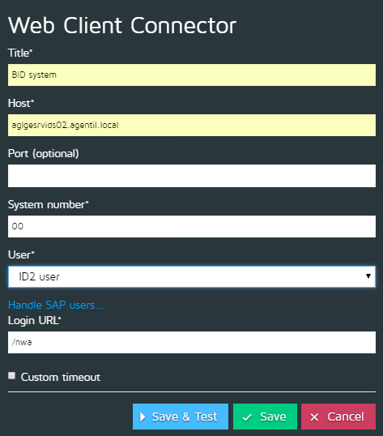

Custom timeout
- See Custom timeouts

