Datadog integration

Architecture
- To visualize SAP monitoring data in your Datadog instance, you need to install a Redpeaks collector in each data center hosting the systems.
- Redpeaks will act as a proxy between your SAP systems and Datadog.
- It will connect remotely to each SAP system and will therefore need to be installed in a network area allowing to do so
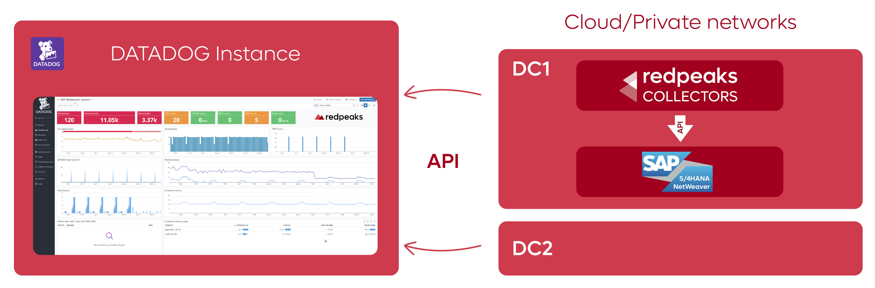

Product highlights
Among the myriad benefits this integration offers, these stand out prominently:
- Agentless deployment:
  - No transports or agent to install on your SAP systems
  - Simplified installation and maintenance
  - No security risks
  - Deployed and configured in 2 hours
  - Compatible with SAP RISE
- Out of the box monitors
  - 80+ monitored components
  - Preconfigured alarms and metrics
  - Out of the box configuration templates
    - NetWeaver
    - HANA
    - BusinessObjects
    - MSSQL
    - Oracle
    - Sybase ASE
    - MaxDB
    - All metrics
    - Custom REST API for BTP/SCPI
- Any kind of deployments can be covered:
  - SAP Rise
  - Private Cloud
  - On premise
- Out of the box Datadog dashboards
- From top level overview to technical details within a single pane of glass:
  - S/4HANA
  - HANA
  - BusinessObjects
- Detailed SAP transaction time per step monitoring
- Without any transport, you will have complete visibility of response time of every transactions
- Ability to inject any SAP metadata as Datadog logs for pattern recognition, and advanced analysis
- Transveral monitoring of business services via advanced correlation mechanism from Datadog
- Leverage Datadog machine learning and AI ops with SAP metrics
- Daily reports of SAP operations
- Instant aggregation of hours to months of metrics, allowing swift navigation and data analysis.
- Out of the box Plugins and monitors allowing multi channels notification and integration

Skills
- Those responsible for installing the solution should have the following skills:
  - Basic linux administration for installing software and creating user accounts
  - SAP basis users & authorizations administration
  - Database users administration
  - Network administration to implement network routes

Prerequisites

Redpeaks
- A Redpeaks license, requested at support@redpeaks.io.
- A dedicated Linux VM with appropriate specs
- Network routes open toward SAP application ports
- A dedicated user created on each system to monitor (See create SAP users and User authorizations details)
- See Redpeaks Prerequisites Documentation for more details.

Datadog
- Allow network communication between Redpeaks server and datadog instance on following endpoints:
  - api.datadoghq.[REGION]:443
  - http-intake.logs.datadoghq.[REGION]:443
- Create API and APP keys allowing Redpeaks application to connect and send data
- Register API and APP keys in Redpeaks plugin

Installation
Insalling and configuring Redpeaks should not take more than an hour if prerequisites are set correctly
- Install the JAVA JRE
- Download the latest Redpeaks package.
- Copy the package into a temporary folder - Not in /opt
- Execute below commands:
tar -zxvf [PACKAGE FILE NAME]
./install.sh
- Redpeaks should be up and running.
- If not, run the following command:
systemctl restart redpeaks

Configuration
You can configure Redpeaks using a web interface:
- Visit http://[REDPEAKS VM HOSTNAME]:8888 in a web browser. The default username/password combination is admin/admin

Install license
- Go to Settings->Licenses
- Copy the provided license keys and Apply License key
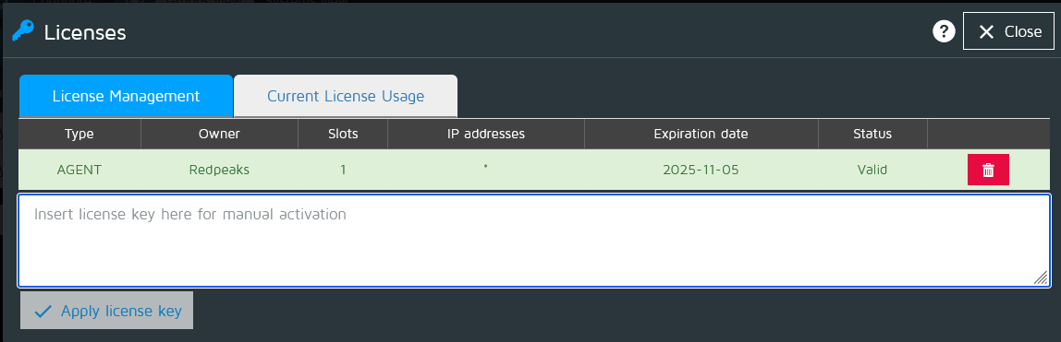

Install drivers
- Get the latest SAP JCO driver for Linux and unzip the file to extract a tgz archive.
- Click the gear icon on the top right to open a menu. Then, select Admin configuration and go the Upload/Download section.
- Click on Install JCO driver and select the driver file (file name similar to sapjco30P_17-10005328_linux.tgz).
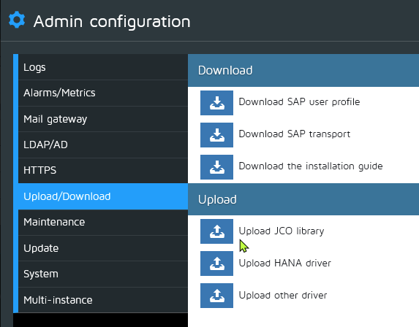

Connection to Datadog
To connect Redpeaks to Datadog, you need first to create keys in Datadog and then register those keys in Redpeaks

Datadog: Create API & APP keys
- You need first to connect to you Datadog instance and create dedicated API and Application keys
- Navigate to the organization settings and use API & APP keys tab to create the keys:
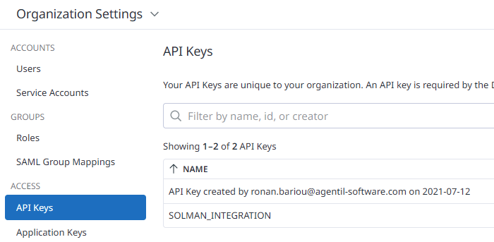

Redpeaks: Register keys in a plugin
- Now you will register the keys within a Redpeaks plugin.
- Go back to Redpeaks web interface and click the top right gear icon and navigate to Plugins.
- Select the Datadog type in the plugin selector and press create.
- Hostname must be as such: : https://api.[sub-region].datadoghq.[Region] (Ex. https://api.datadoghq.eu or https://api.us5.datadoghq.com)
- Set your Datadog API and APP keys and save
- Redpeaks is now connected to your Datadog instance.
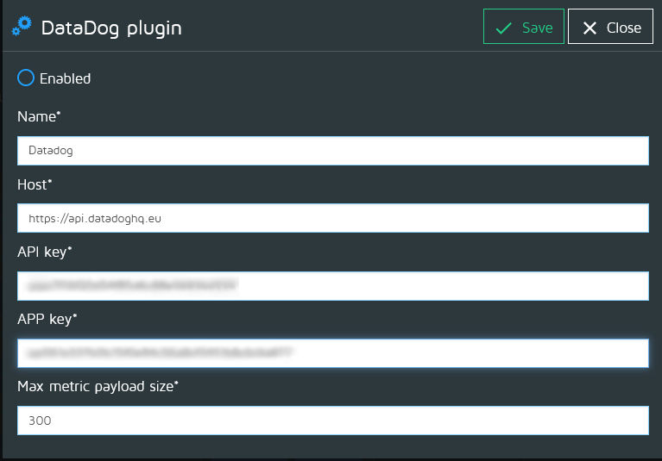

Connection to SAP
For connecting Redpeaks to a SAP system, you will need first to create a group, a system, a user and a connector.
- Create your first group
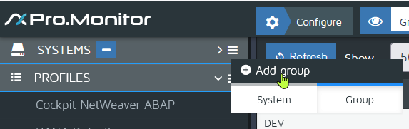
- Fill the group formular
- Don't foget to set group shortname and company shortname:
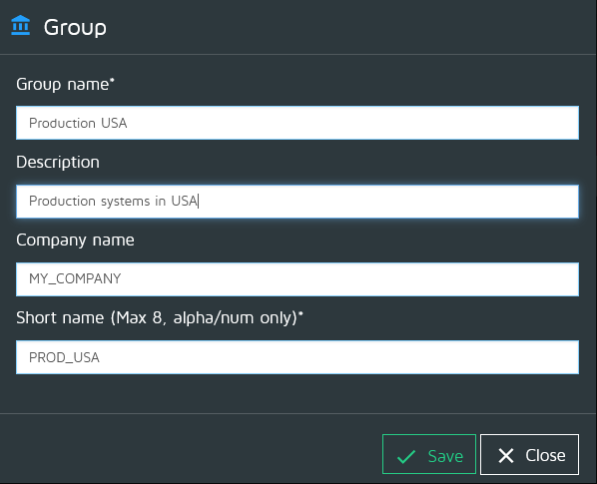
- You can now create your first system
- From the group contextual menu, select “Add system”
- Select the appropriate system
- Don't forget to set system shortname
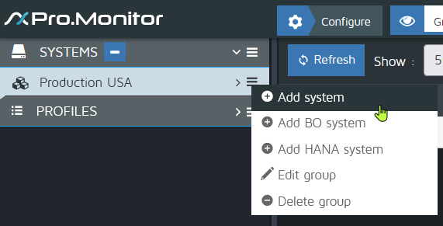
- Now you can create a user
- From configure menu, select add user
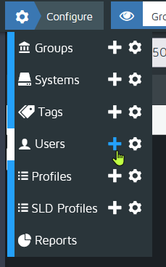
- User profiles are associated to a group
- It will be used later when creating a connector
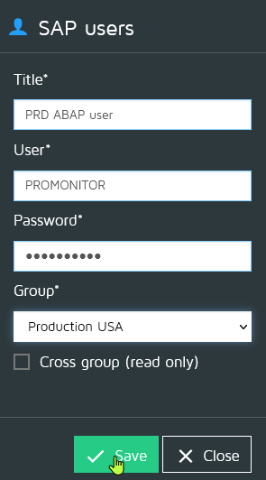
- Now you can create connector
- From the system contextual menu, select “Add connector”
- Select the appropriate connector type
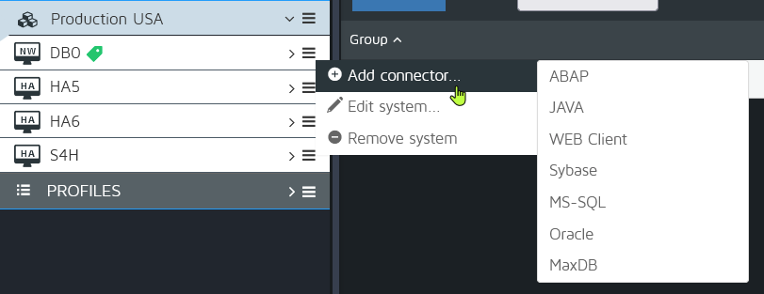
- Then fill the connector form
- The connector holds the necessary connection parameters to reach the system
- Press Save&Test, you should see a green popup indicating a successful connection
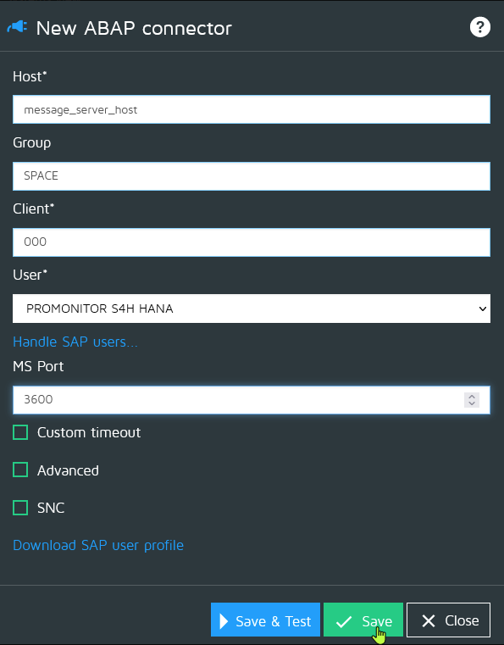

Configure monitoring
The monitoring of SAP systems is done via monitoring profiles
- Create your first profile
- You can import, create and customize profiles from the profiles section on the left
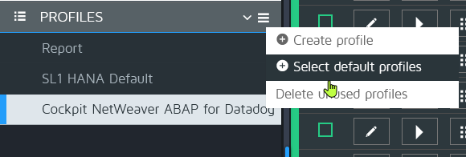
- From the profiles menu, select Select default profiles
- Select the Datadog profile and press Save.
- The imported profile will appear in the list of profiles
- Now you can assign your profile via the assign button
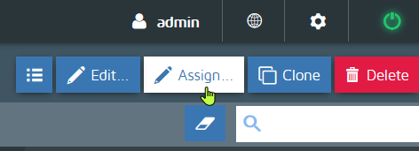
- From the assign menu, just move the available connectors from right to left, then save.
- Your connectors are now associated with a set of predefined monitors
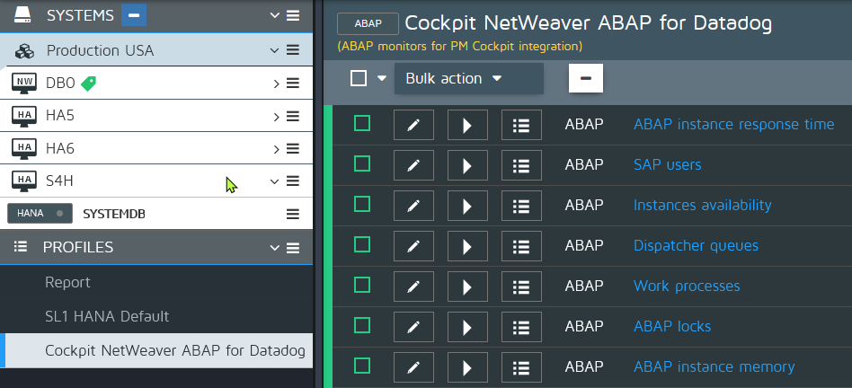
- Last step: Activate the monitoring:
- Select a connector and press “Start monitoring”
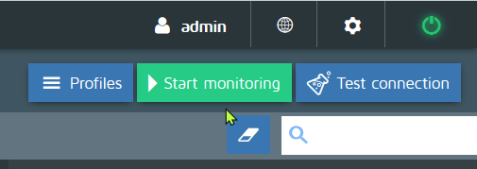
Monitoring is now active for all your systems, which you should see in Datadog.

Dashboards
- Once you activate the integration from the marketplace, predefined dashboards will appear in your Datadog instance.
- This is a link to the latest dashboards

Support
For support or feature requests, contact AGENTIL Software at support@redpeaks.io

FAQ

What are the advantages of the HANA integration vs native integration:
- Compared to native integration, our solution will provide the below advantages:
- Agentless monitoring: No need to install or manage an agent on individual SAP systems.
- Centralized configuration: Manage and control system monitoring through a central web-based interface.
- Predefined configuration templates that can be deployed across multiple systems simultaneously.
- Flexible capabilities to extend monitoring to include additional metrics and modules with ease.
- Expert support team available to assist with specialized customer use cases

