Introduction

What is Redpeaks ?
Redpeaks is a monitoring solution primarily dedicated to SAP technologies and the associated databases. Its purpose is to monitor the health and performance of these applications to ensure the highest quality of service.
Redpeaks is preconfigured with a monitoring library based on monitoring best practices and designed to be efficient and simple to use.
It will remotely connect to the systems, collect and analyze data and generate monitoring information such as alarms, metrics and reports.
Redpeaks can be configured to connect and forward those information into third party platforms such as ticketing systems, monitoring frameworks or productivity solutions already in place.

Monitored technologies
- SAP NetWeaver ABAP/JAVA
- SAP S/4HANA
- SAP HANA
- SAP Business Objects
- SAP ASE database (Sybase ASE)
- Oracle database
- MSSQL database
- Cloud connector
- BTP/CPI
Read detailed information about :
- Terminology

Architecture

Overview
- Redpeaks is composed by a server with an internal database, holding the monitoring configuration
- The server integrates a monitoring engine executing monitors, for checking systems in real time.
- An embedded monitoring library provides default profiles, helping to configure and customize the monitoring
- An embedded web server is used for the user interface and can be reached via a web browser
- By default, Redpeaks is standalone, but it can also be used in a “Multi-instance” mode, with several agents and a central instance.
- An high availability architecture is also available and can be implemented for both standalone and multi-intance.
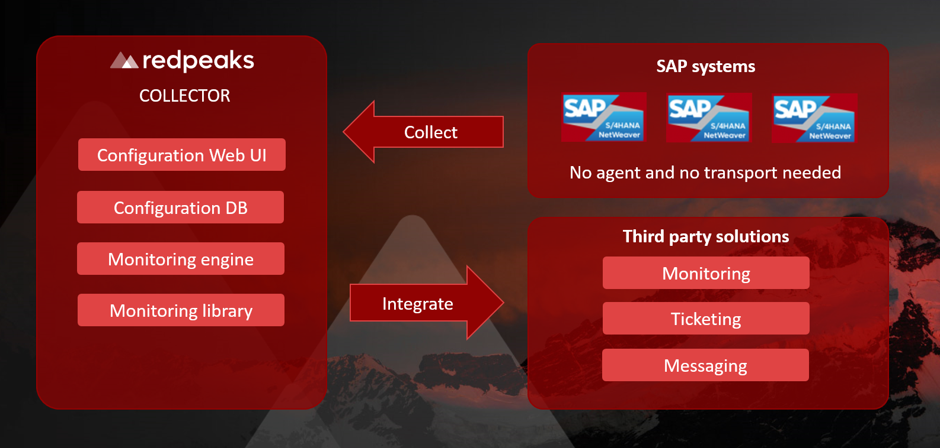

Multi instance
- In order to cope with scalability and network constraints, Redpeaks server can be configured to work with a grid of agents
- One instance can be configured as central server and several instances can be set as agents
- The server will control the configuration and dispatch workloads to agents
- Agents can be used to improve resilience, increase processing power or access to systems within an isolated network.
- Communication between server and agents will always be initiated by the agents, allowing to cope with security constraints when the server is not located in the same network than the systems
- In this scenario, communication between agents and server will always be initiated by the agents, allowing to host the server in a public network while keeping the agent in a private one.
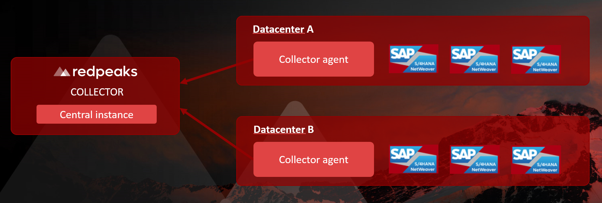

High availability
- High availability is achieved by deploying two instances of the collector: one primary and one secondary.
- Both instances run the same software, the collector role is configurable in the admin settings.
- While the primary server is active, its configuration is continuously replicated to the secondary instance.
- The secondary instance remains passive until the primary fails to respond or stops producing monitoring data.
- In the event of a failover, the secondary instance automatically takes over to ensure monitoring operations continuity, using the most recent configuration.
- A failover situation can easily be reverted once the primary instance is back online, simply switch secondary instance to standby mode.
- See detailed description


