Architecture

Overview
- Redpeaks is composed by a server with an internal database, holding the monitoring configuration
- The server integrates a monitoring engine executing monitors, for checking systems in real time.
- An embedded monitoring library provides default profiles, helping to configure and customize the monitoring
- An embedded web server is used for the user interface and can be reached via a web browser
- By default, Redpeaks is standalone, but it can also be used in a “Multi-instance” mode, with several agents and a central instance.
- An high availability architecture is also available and can be implemented for both standalone and multi-intance.
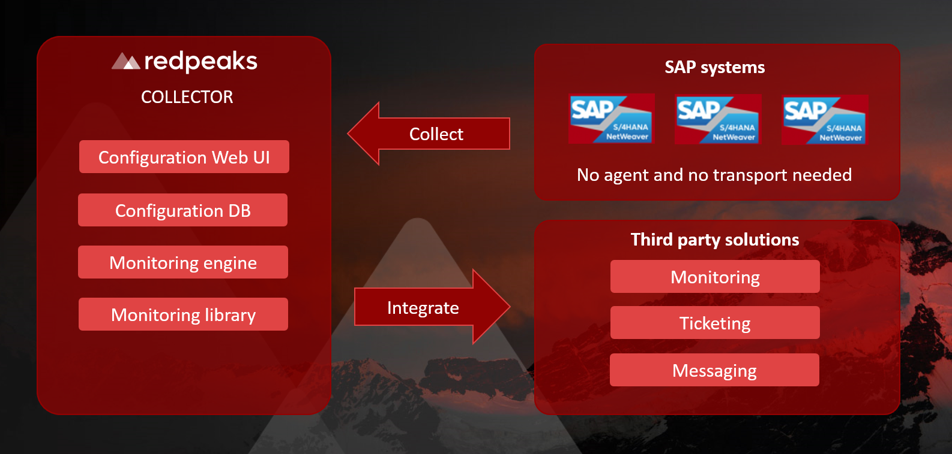

Multi instance
- In order to cope with scalability and network constraints, Redpeaks server can be configured to work with a grid of agents
- One instance can be configured as central server and several instances can be set as agents
- The server will control the configuration and dispatch workloads to agents
- Agents can be used to improve resilience, increase processing power or access to systems within an isolated network.
- Communication between server and agents will always be initiated by the agents, allowing to cope with security constraints when the server is not located in the same network than the systems
- In this scenario, communication between agents and server will always be initiated by the agents, allowing to host the server in a public network while keeping the agent in a private one.
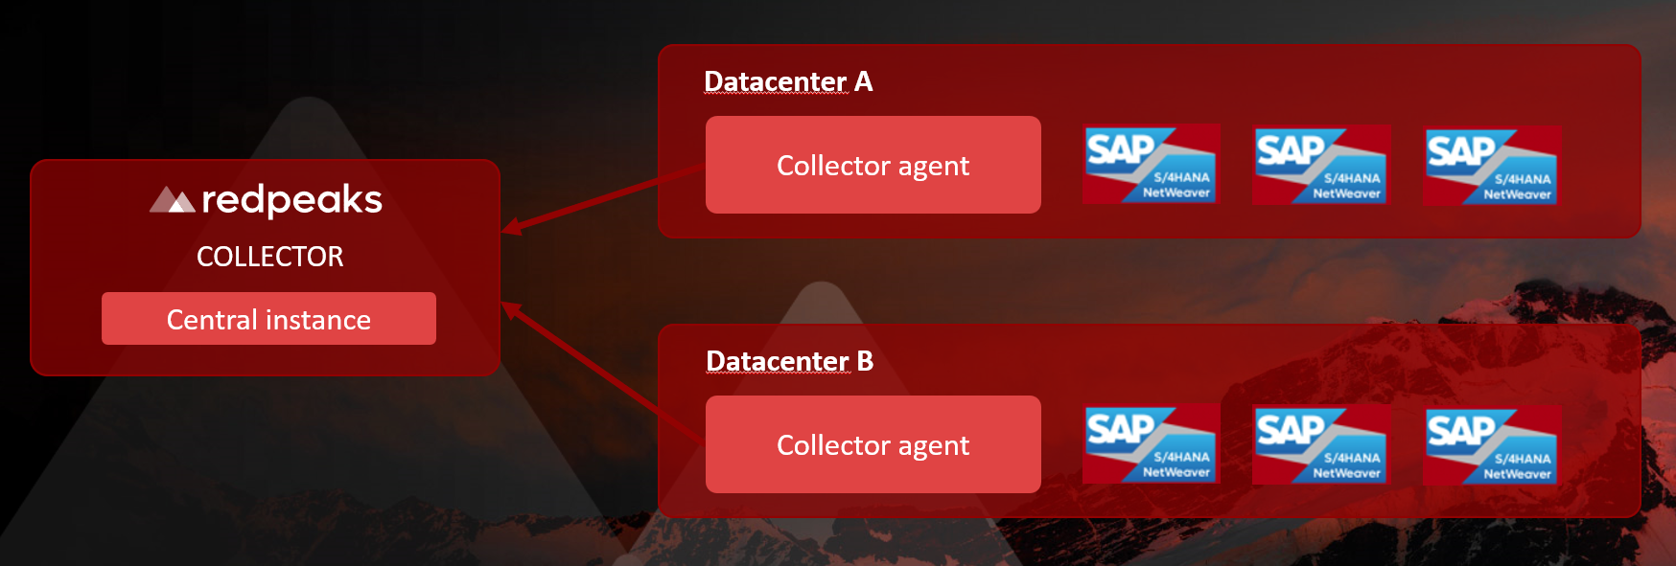

High availability
- Redpeaks servers can be setup as primary or secondary server.
- When set as secondary, the server will connect to a primary server to regularly sync its configuration.
- If primary server stops responding or stops producing results, the secondary server will take over and continue monitoring operations.


