Architecture

Overview
- Pro.Monitor is composed by a server with an internal database, holding the monitoring configuration
- The server integrates a monitoring engine executing monitors, for checking systems in real time.
- An embedded monitoring library provides default profiles, helping to configure and customize the monitoring
- An embedded web server is used for the user interface and can be reached via a web browser
- By default, Pro.Monitor is standalone, but it can also be used in a “Multi-instance” mode, with several agents and a central server.
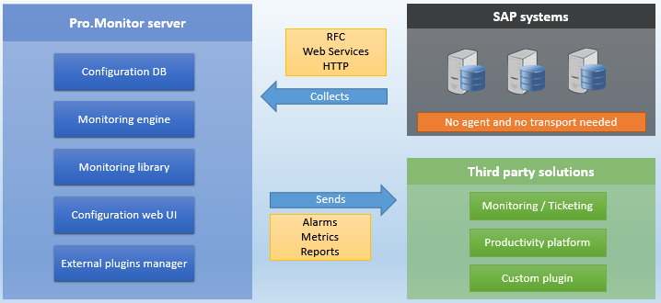

Multi instance
- In order to cope with scalability and network constraints, Pro.Monitor server can be configured to work with a grid of agents
- One instance can be configured as central server and several instances can be set as agents
- The server will control the configuration and dispatch workloads to agents
- Agents can be used to improve resilience, increase processing power or access to systems within an isolated network.
- Communication between server and agents will always be initiated by the agents, allowing to cope with security constraints when the server is not located in the same network than the systems
- In this scenario, communication between agents and server will always be initiated by the agents, allowing to host the server in a public network while keeping the agent in a private one.


