Administration
- The configuration of global settings of Pro.Monitor is done via the settings menu:
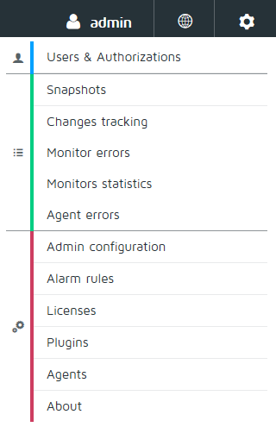

Settings
- Tags : Tags management
- Users and authorizations : Grant access to the application
- Snapshots : Import, export and backup your configuration
- Change tracking : Watch the changes done in the monitoring configuration
- Monitor statistics : Shows execution statistics of the monitors
- Alarm rules : Manage how alarms are propagated through plugins
- Licenses : Install and check your licenses
- Plugins : Send alarms and metrics to other applications or by email
- Agents : Manage your agents and their associations

Admin Configuration
Admin configuration is a sub-menu of the settings menu reachable by admin user only. It gives access to the internal settings of Pro.Monitor
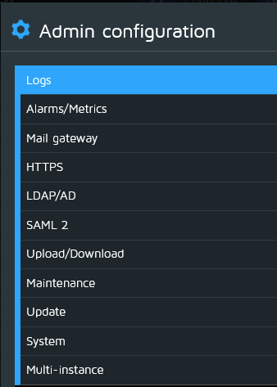
- Logs : Manage log level and download log files
- Alarms and Metrics : Configure default global thresholds and severities
- Mail gateway : Allows the application to send emails
- LDAP : To authenticate Pro.Monitor users via LDAP
- SAML2 : Configure SSO with SAML2
- HTTPS : Configure HTTPS settings and import certificates
- Upload/Download : Upload JCO/HANA drivers and get SAP authorization profiles
- Maintenance : Manage maintenance message and application restart
- Update : Download and Install Pro.Monitor updates
- System : Configure system parameters
- Multi-instance : Configure the instance mode.

