3. Web client connector

Purpose
- This connector will give access to the administration portal
- It can be used to check that the portal is responding and also to collect and analyze information from any of its sections

Create user profile
- User profiles can be reached via Systems-> SAP users
- Once created, the user profile can be selected in the connector form
- Note: A user profile is by default associated with a company . You can explicitly set a profile to be cross companies. The effect is that it will be selectable from connectors of any companies
- Create the corresponding user in SAP in order to have access to the portal

User authorizations
In case of the user management engine (UME) referred to a data source served by an ABAP client stack, the user account to access PI/XI information in the web portal must meet the following prerequisites:
- The web client connection user must be created in the client of the UME associated ABAP system (normally it is the “production” client, ask to the users administrator).
- Following roles must be granted to the user: SAP_XI_DISPLAY_USER_J2EE, SAP_XI_RWB_SERV_USER (exclusively, DO NOT USE A COPY)

Create connector
- Select the system in the Systems tree and select “Add connector” in its contextual menu, choose Web client type:
  - Title : The name of the instance
  - Host: The CMS’s host
  - Port (optional): Host opened port number
  - System number: SAP system number
  - User profile: Redpeaks SAP User name
  - Login URL: The section of the portal in which you want to login. By default it will connect to the netweaver administration section.
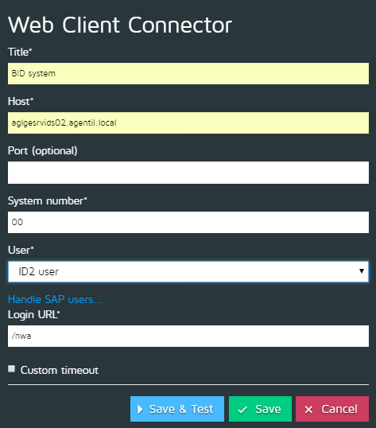

Custom timeout
- See Custom timeouts

